WINGSPAN BIRD TOURS

IN

COSTA RICA

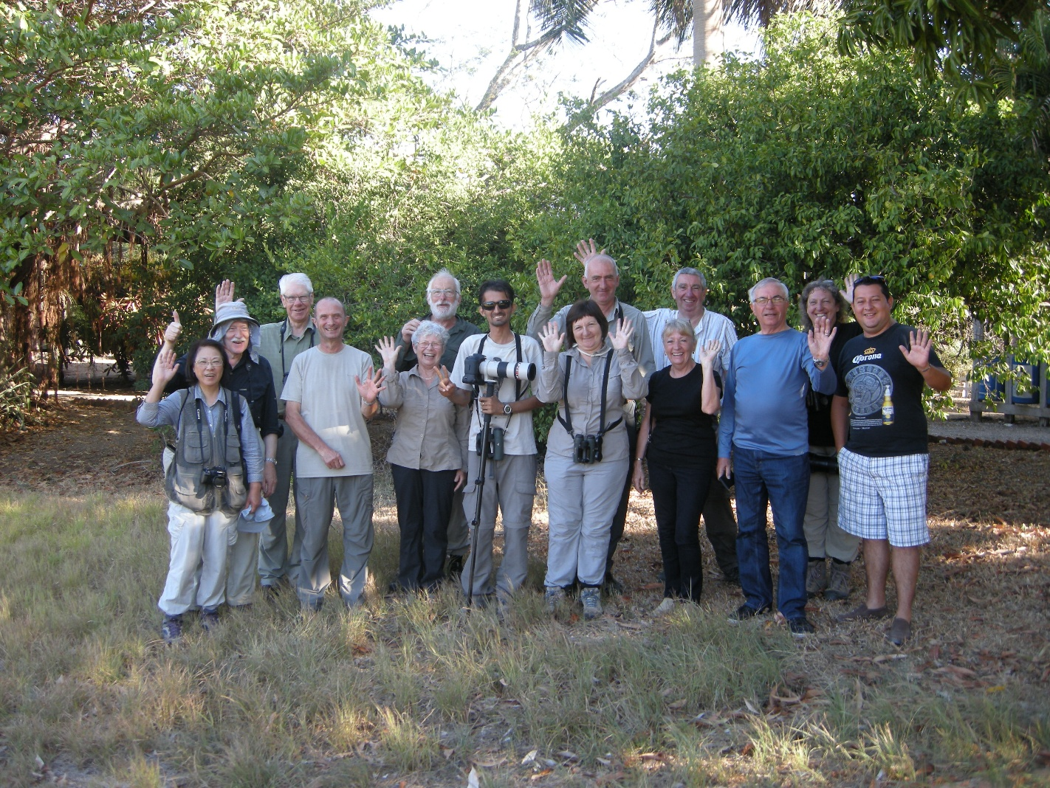
TRIP REPORT

FEBRUARY 19TH – MARCH 6TH 2015

LEADERS: BOB BUCKLER & ROY OROZCO with JOHAN FERNANDEZ (2 days)

PARTICIPANTS: BOB LONGHORN, SANDRA & IAN WALLACE, APRIL & BILL GOUDIE, PAUL & EDNA LOCK, GILL & JOHN STACEY, PAUL EDLIN, ROY SMITH & WINNIE POON.

SUMMARY & REPORT WRITTEN BY BOB BUCKLER

This was the fourth exciting WINGSPAN TOUR of Costa Rica and although we did not top the species total of last year’s impressive list of 463 we had a great time trying. A lovely group of people made this trip something special for myself and Roy, plenty of laughs along the way as we visited some fantastic birding locations. Resplendent Quetzal was voted bird of the trip but several species came a close second such as: Red-headed Barbet, Buffy Tuftedcheek, Fiery-billed Aracari and Acorn woodpecker which all received votes.

Everyone had their special moments during our two weeks of memorable experiences with some delightful wildlife watching found nowhere else in the world. The boat trip along the Tarcoles River was magical, the hummer feeders at Rancho, Cinchona, Talari and Savegre were mesmerising and the variety of habitats provided an endless stream of bird species giving us memories to treasure for a very long time and thousands of photographs to cherish forever.

DAY 1 – 19TH FEBRUARY 2015 – SAN JOSE AIRPORT HOTEL TO BOUGAINVILLEA HOTEL.

Sunny, warm but very windy all day.

As all of the group opted to arrive a day or so early we were already in Costa Rica on day 1 of the tour, nine of us were staying at an airport hotel whilst the other four were at the starting point of the tour, the Bougainvillea Hotel.

The larger group of nine (including me) had a few hours to spare before the transfer bus arrived so we went for a short walk to a stream near the hotel. We soon got a fair list of species starting in the car park of the hotel where we saw the beautiful Rufous-naped Wren together with White-winged Dove, Rufous Collared Sparrow, Blue and White Swallow and the very common Great-tailed Grackle.

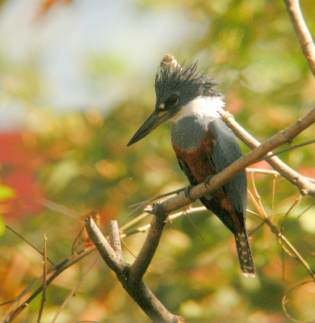
In some scrub near the pool we found Yellow Warbler, Blue and Grey Tanager, Clay-coloured Thrush and Rufous-tailed Hummingbird. We then found a vantage point where we could scan the stream and from there we added a few new species to our list including, Black Phoebe, Grayish Saltator and Common Ground Dove. Hoffman’s Woodpeckers were everywhere, at least 5 were flying around near us.

A few birds were noted as flyovers; Great and Snowy Egrets, Turkey and Black Vultures and a single Yellow-headed Caracara. A little patience produced Ringed Kingfisher at the stream and a couple of Tennessee Warblers showed well feeding in palm trees as we walked back to the hotel.

We checked out at 11am, boarded the bus and set off for the Bougainvillea hotel, Roy our Costa Rican guide also joined us. Our transfer went uneventful except for the sighting of many common species already listed and a Cattle Egret. We stopped for lunch in the metropolis of San Jose before arriving at the hotel around 1pm.

After checking in and meeting up with the four remaining group members all 14 of us set off to explore the extensive and well-manicured gardens. Despite the strong, gusty wind we still managed to see a number of species including several new ones for the list. The resident Rufous-capped Warbler is high up there in the beauty stakes, so is Yellow Warbler, Blue-crowned Motmot and Summer Tanager, all were seen well. A flyover White-tailed Kite was nice and several species were seen by just a few of the group as is usually the case when we are strung out along a path, even the leaders do not see everything. Philadelphia Vireo, Ruby-throated Hummingbird, Baltimore Oriole, Rufous-collared Sparrow, Social Flycatcher are examples of this.

Further walking around the ponds produced a few more species we all had good views of Hoffman’s Woodpecker, Rufous-tailed Hummingbird, Greater Kisskadee, Blue and Grey Tanager and flyover Crimson-fronted Parakeets, the latter had a roost site in front gardens where 100+ would gather each evening.

We broke up around 4pm and met up again at 6:30pm for the bird-log and then dinner, which was excellent, this was followed by a night walk in the Gardens which produced some interesting finds, mainly frogs but also Tropical Screech Owl and Ferruginous Pygmy Owls.

So day one ended on a high note and tomorrow we set off on our exciting journey around this beautiful country.

DAY 2 – 20TH FEBRUARY 2015 – BOUGAINVILLEA HOTEL – BRAULIO CARRILLO NATIONAL PARK – SELVA VERDE LODGE

WEATHER: Dry and sunny for an hour! Then rain all day.

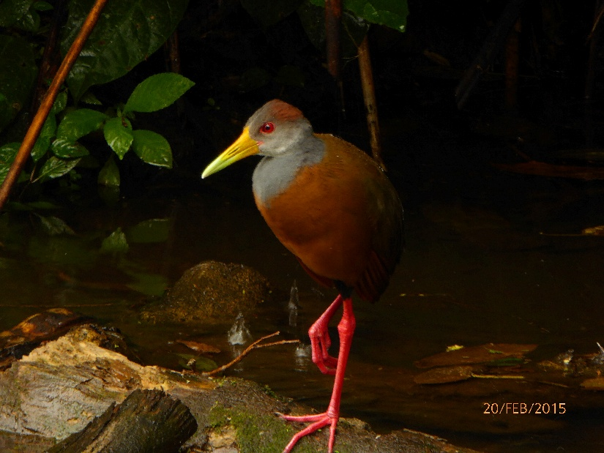
Well what a turn up, the wind had dropped and at 6am it looked as though it was going to be a lovely day, however by 7am it clouded over and as we left in the bus at 8 it started to rain and it never stopped all day.

It took about an hour to get to our first destination, Braulio Carrillo National Park, this hugh area of rain forest is up in the clouds and today it was dull, misty and very wet. We parked in a small sub-entrance to the park and found shelter on the veranda of a disused dwelling where we could see out over a clearing which was once a garden, many flowering plants were growing there.

Our second resident warbler sighting, the Buff-rumped Warbler, flitted about near the far end of the veranda and despite the rain Hummingbirds began to appear, in fact we had a very nice hour watching several species which included the diminutive Snowcap (female), other species included: Rufous-tailed Hummingbird, Bronze-tailed Plumeleteer and Green Thorntail.

Not too many other birds were seen and for obvious reasons we decided not to go walking in the Rain Forest, instead we stood on the veranda watching Silver-throated Tanager, Bananaquit, Chestnut-sided Warbler and Tropical Kingbird.

Then Roy pulled off a master-stroke, he called a friend who lives locally and who has a bird hide in his garden, he agreed to let us use it, so off we went down into the valley on the Caribbean side of the national park. The bird hide was fantastic, we could all fit into it nicely and Copé the owner had put up hummer feeders and fruit out for the birds. Despite the dull light and the rain the photographers in the group were in heaven.

Several species of hummers came to feed including the Long-billed Hermit, also a variety of tanagers, two species of
Oropendola, the Montezuma looking magnificent at close range and the Chestnut-headed showed briefly . There was also rice put out on the ground and this attracted the elusive Grey-necked Wood-Rail, we had unbelievable views of that beauty.

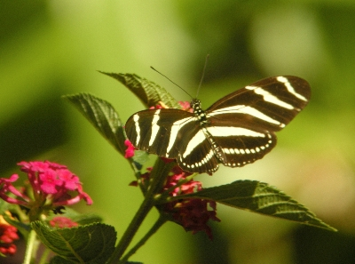
Also in the garden we saw Wood Thrush and a Wood-Rail sitting on eggs, Copé knew his local area very well and offered to take us for a walk to look for Owls. The rain had eased a little but it never stopped, we were all well kitted out in water-proofs and boots.

It took us a while but we saw up to three Spectacled Owls, a Fasciated Heron on the river, also a Broad-billed Motmot and a roosting Great Potoo. In the tree tops we saw more Oropendolas, Black-mandibled Toucan and not much else.

We went off to lunch to a roadside restaurant and for the last 3 hours of day light Copé took us to another area of forest to look for Crested Owls. The forest was found along a track some 10 kilometers long and all along it we made several stops to look at interesting birds. Again we logged some nice species but failed to see the owl. The highlights of our sightings were Yellow-crowned Euphonia, Variable Seedeater, Roadside Hawk and Yellow-bellied Flycatcher.

In the forest we walked a couple of trails without seeing much and throughout our walk we endured persistent rain, eventually we gave up and returned to the bus. Our journey back along the track to the main road was lengthened by several stops, we found Green Heron, Southern Lapwing and Grey-capped Flycatcher.

We arrived at the Selva Verde lodge at 6pm and after a short settling-in period we went to dinner in the impressive dining hall.

DAY 3 – 21ST FEBRUARY 2015 – LA SELVA ALL DAY

Weather: rain at first then dry with sunny spells

It rained all night (so I’m told) and it was still raining when we met on the veranda just outside of the dining room from where we could see the river and an open area where bird feeders were stocked with lots of fruit.

A few Passerini’s Tanagers dropped in as did a Grey-headed Chachalaca but a couple of mammals came down and devoured most of the fruit, they were Variegated Squirrel and White-faced Coati. An Orange-billed Sparrow made a few fleeting appearances as did Red-throated Ant-Tanager but the strangely-beautiful Montezuma’s Oropendola gave us stunning views along with the vibrant Summer Tanager a bird that shone in the dull, wet forest setting.

After a short walk, during which we all got a little wet, we settled down for breakfast which was a lovely affair with a wide choice of food. At 8am we were all finished and promptly loaded onto the bus for our day out to La Selva. This biological station consists of miles of forest trails and two or three large open compounds with accommodation for studying students, field study centres and dining areas, a large ‘steel-rope’ bridge spans the River Saripiqui and circular trails lead off in several directions on either side of the river.

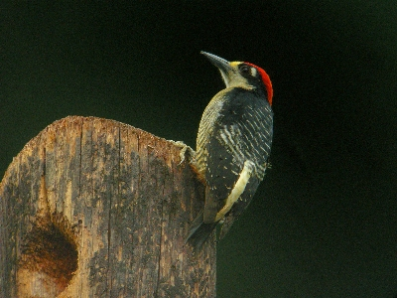
As we arrived the rain stopped, a miracle! We all jumped off the bus along the approach track to La Selva to look at a Grey-headed Kite which had perched in the open and as usual one bird led to many other sightings including this Black-cheeked Woodpecker (left).

We were greeted by our guide for the day, Manuel, who began with a short speech about the centre and the trails, we then spent the first hour around the main compound as Manual and Roy pointed out several excellent species, the best of which included Paltry Tyrannulet, GREAT GREEN MACAW, Dusky-faced Tanager, Olive-backed Euphonia, Collared Aracari and so many more.

Our walk started but we didn’t get far as a Rufous-tailed Jacamar held us up by perching out in the open and the another star bird appeared, the beautiful all white SNOWY COTINGA, what a stunner. We also saw a Black-billed Toucan in the distance.

We followed a track that led through the forest making frequent stops and I can’t list all of our sightings as they were too numerous but I can say we had a superb morning, the light improved all the time and eventually the sun came out, hooray. It was because of the recent, prolonged rain that the birding was so good.

A pair of Band-tailed Barbthroats tended their hanging nest, a few giant Iguanas sat high up in the trees and all kinds of exotic motmots, toucans, parrots, jacamars were found in all levels in the forest. On the ground we saw Poison Dart Frogs, some beautiful butterflies and a few brightly coloured flowers.

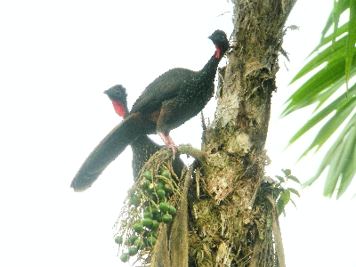
Back at the compound we had a much appreciated cooked lunch and at 1pm we were back on the trails, this time we crossed the river using the ‘canopy-bridge’ which brought us into an open compound where the field study centre was situated and it was mammals that drew most of our attention to start with. We were shown some Long-nosed Bats, a Three-toed Sloth, Variegated Squirrel and a small heard of semi-tame Peccary. Once on the track we found a Tyra and a Coati and a lot of nice butterflies.

You would think that birding in the mid-afternoon in the rain forest would be uneventful but it certainly wasn’t the case today we found many bird species as well as Spider Monkeys and Red Howlers.

The main highlights were Purple-throated Fruitcrow, one was seen and heard but in poor light, Olive-Backed Quail-Dove, it was very hard to see on the forest floor, Black Currasow on the track, a couple of nice wrens, White-breasted Wood-Wren and Stripe-breasted Wren. We also saw well, Rufous and Broad-billed Motmot, Rufous-tailed Jacamar, another superb Snowy Cotinga, White-collared Manikin and several woodcreepers, woodpeckers, tanagers and flycatchers. It was a superb day out in a wonderful place, everyone enjoyed themselves.

Before we left to return to our lodge we stopped in a side entrance to the park where open fields had some huge trees sparsely scattered about. We scanned the trees and found A couple of Bat Falcons, a Great Green Macaw, Black-mandibled Toucan and many Orange-chinned Parrots. This finished off a superb day-out, we had listed 85 species and nearly a dozen mammals!

DAY 4 – 22ND FEBRUARY 2015 – SELVA VERDE – CINCHONA ( LA VIRGEN)

Weather: a beautiful clear morning to start then cloudy later.

We met at 6am for a walk along the trails of Selva Verde, it was a little misty but dry and after watching the bird feeding station for a while we set off into the forest along the ‘river’ track. A couple of Amazon Kingfishers flew by as we approached the water’s edge and then a SUNBITTERN was found on the far shore, we had excellent views of this strange looking bird before it flew off up river, it flew passed us by showing off its’ lovely wing markings from where it got its’ name, what a great start to our day
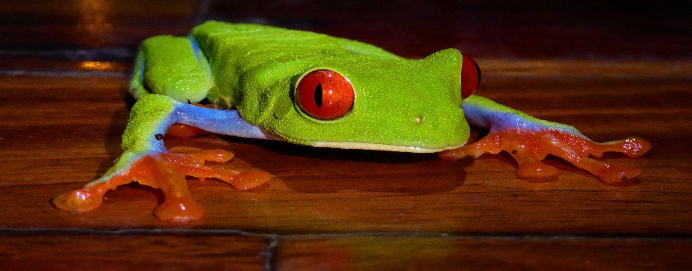

Other good birds seen during our walk included Bright-rumped Attila, White-necked Manikin, Red-throated Ant-Tanager and we saw a distant Keel-billed Toucan, this has to be the most colourful all of Costa Rica’s birds.

We continued our walking at Selva Verde after breakfast, this time we crossed the river and the main road to reach the Botanic Gardens, an area of exotic plants and many flowering shrubs and bushes. It was alive with birdlife, one particular fruiting tree held 10 species! We ‘scoped’ Golden-hooded Tanager, White-vented Euphonia, Shining Honeycreeper, Buff-throated Saltator and Green Honeycreeper which was another new species for our list.

Several ‘hummers’ darted about, the Striped-throated Hermit was new for us as was a number of Woodcreepers, Plain-brown, Coccoa and Wedge-billed Woodcreepers we all seen well. We then walked a track that led us to an open area that had a large pond and several research buildings, the pond produced another Kingfisher, the Green variety and also a large Black River-Turtle (Rhinoclemmy’s funerae).

After a short rest we gathered again and boarded the bus for the hour long drive to La Virgen, an area of much higher elevation with steep sided forested-gorges and open pasture. Spectacular waterfalls seemed to be a feature in most the valleys. We stopped a couple times to look at various species the first stop was at a bridge that spanned a fast flowing river. The water was littered with large rocks and standing on a large boulder was a Fasciated Heron. We also found Black Phoebe and Torrent Tyrannulet, just before we boarded the bus a White Hawk was seen circling in the distance.

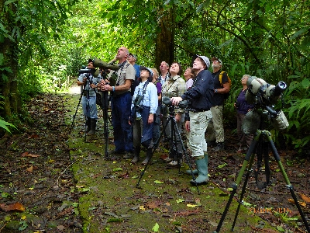
Finally we climbed to the top of La Virgen Valley where a restaurant had a superb ‘Galerie de Colibries’ a ‘gallery of Hummingbirds’ which was a wooden terrace that looked over the valley giving panoramic views which included a spectacular waterfall. The platform had many ‘hummer’ feeders and a large feeding station. It was buzzing with all types of birds, we added six new hummingbirds to our list including the Endemic COPPERY-HEADED HUMMINGBIRD. It was fantastic to see so many birds at such close quarters, the bird table attracted many tanagers, we added the Crimson-collared Tanager and Common Bush-Tanager to our list but seeing Silver-throated, Palm. Blue and Grey and Passerini’s so close was magical.

The restaurant served us lunch on the terrace whilst hummingbirds flitted around us, what a great setting and a unique experience. Following lunch we drove down into the valley along a side-track, we parked the bus and continued on foot. In the past Wingspan Tours had found many excellent species during this walk but today was very quiet and it was not until we approach the bottom of the valley that birds began to appear. A Slate-throated Redstart was first to appear followed by a pair of Tufted Flycatchers, some of group saw a Scale-crested Pygmy-Tyrant and then a Yellow-margined Flycatcher appeared.

A couple of Trogons caused a great debate, were they Orange-bellied Trogons or Collared Trogons? These two species have ranges that overlap and are virtually identical except for the colour of the belly, red or orange? This is of course is very subjective and also a light-dependent issue, Roy proved his identification diagnosis by playing the call of the Orange-bellied variety and got an immediate response.

We had another sighting of the White Hawk and had superb views of a perched Grey Hawk as we climbed out of the valley. Wet then returned to Restaurant’s Hummingbird’s Terrace in the hope of seeing one or two species that were missing from our list. The Regional Endemic - Prong-billed Barbet, finally showed up at around 4:15 pm, fantastic but we never did see the Emerald Toucanet, oh well you can’t win them all! But whilst waiting we enjoyed the hummers again and a flock of Montezuma’s Oropendolas was nice to see perched so close as well as White-crowned Parrots and Black Vultures.

We arrived back at Selva Verde around 6pm and met up at 7:30pm for dinner, our meal was interrupted when a shout went up of “Woolly Opossum”! We all dashed out onto the veranda to see this nocturnal gem, there it was climbing down a vine to the feeding station, another excellent mammal species added to the list.

DAY 5 – 23RD FEBRUARY 2015 – SELVA VERDA – BRAULIO CARILLO – TRANSFER TO RANCHO NATURALISTA

Weather: dry, sunny and warm.

There was no official pre-breakfast walk arranged today but some of the group went to the river to look for the SUBBITTERN again. They were rewarded with great views of it and one lucky couple had the bird land within 5 meters of them. Other species seen along the river were Spotted Sandpiper, Buff-rumped Warbler, Fasciated Tiger-Heron and an Anhinga. Flocks of egrets flew over as they left a nearby roost.

By 8am we were all packed, breakfast was over and we set off for our next destination, Rancho Naturalista some 3 hours away. But first we planned to stop at Braulio Carrillo to walk the forest trail that we abandoned a few days ago due to the heavy rain. Along the way to Braulio we made a quick stop to look for Nicaraguan Seed-Finch in some open grassland, the Finch didn’t show but we added Eastern Wood-Pewee, Bare-necked Tiger-Heron and Groove-billed Ani to our list and we saw a number of other species including a fly-over Crested Caracara.

We arrived at Braulio in bright sunshine, we parked at a private entrance where a well-tended garden held many flowering plants, this attracted many ‘hummers’ to our great delight, no new species were seen but good views of several we recognised.
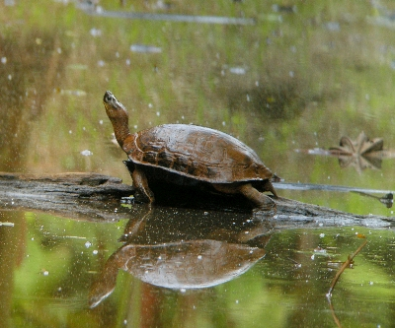
The forest walk was hard going, a bit muddy and it had many natural obstacles like fallen trees and steep, muddy steps in places. We were rewarded for our efforts with sightings of a LATTICE-TAILED TROGON, this beautiful bird has a restricted range so we were lucky to see it. We then found a feeding flock high up in the canopy, a number of tanagers included Emerald and Tawny-crested, we also saw Tawny-capped Euphonia and White-throated Shrike-Tanager for the first time.

From then on sightings were few and far between until Roy found another feeding flock, he called out “Sharpbill, Sharpbill” and got very excited, but unfortunately only he could see it, what a pity this was a rare sighting indeed! We did see Tennessee Warbler, Chestnut-sided Warbler, Green Honeycreeper, Olive-backed Euphoria and some tanagers, but not the Sharpbill.

Other species of note were few, White-Ruffed Manakin, Lesser Greenlet and Black-Mandibled Toucan come to mind but not much else. Back at the garden where the bus was parked we found a Black-crested Coquette, a great little ‘hummer’ to finish off our morning.

We had a lovely lunch at a roadside restaurant and by 2pm we were on the road again heading for Rancho, the journey took a further 2 ½ hours, we passed through some lovely countryside as we climbed to about 1000 meters.
Rancho is situated high up in the hills along a 3km steep track – I’m glad we weren’t walking!

It was around 4:30pm when we all assembled on the famous Rancho ‘veranda’, the ‘hummer’ feeders were still busy and the garden held a number of flowering plants which were also being visited by hummers, it was on these flowers that a male SNOWCAP was found, what beauty that bird is. We also saw Green-breasted Mango, Crowned Woodnymph, White-necked Jacobin and Green Thorntail.

Dinner was served early at 6pm on the terrace, we had a lovely relaxing evening, some of the group went out later looking for a Mottled Owl and were successful with good sightings near the accommodation cabins.

DAY 6 – 24TH FEBRUARY 2015 - RANCHO NATURALISTA ALL DAY

WEATHER: clear and sunny with some cloud, warm all day

We met at 5:30am on the veranda of the main building at Rancho Naturalista, coffee and Tea was waiting, it was just getting light and the hummers were stirring. Grey-headed Chachalacas were first to arrive at the bird-feeding stations but generally it was slow going.
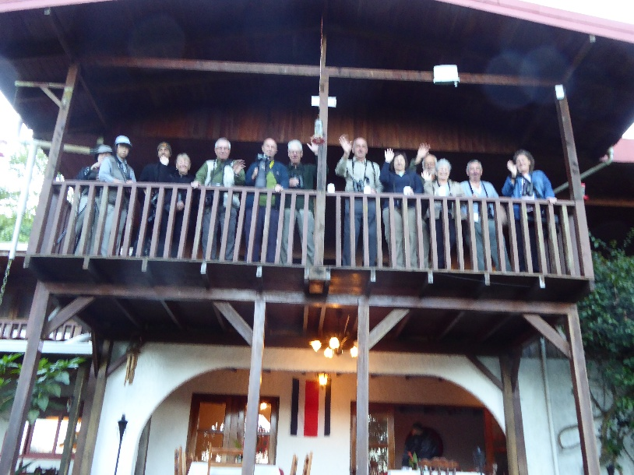
Eventually it started to get busy with hummingbirds, White-necked Jacobin, Green-breasted Mango, Stripe-throated (Little) Hermit, (Violet) Crowned Woodnymph, Brown Violetear, Snowcap, Green Thorntail and Black-crested Coquette all put in an appearance. We also saw Orange-billed Sparrow, Bananaquit, Brown Jay and Montezuma’s Oropendola.

Breakfast was served at 7am on the terrace from where we could still see the garden and the feeders, at 8am we were on our way to the nearby forest trails. Again it was slow going not many species to look at, we heard a Thicket Antpitta but couldn’t coax it out and Roy pointed out a Hepatic Tanager. A little further along the forest trail we bumped into a small feeding flock of Tanagers where we added Bay-headed Tanager to our collection and we had good views of Golden-hooded Tanager.

Other species were few and far between until we hit another small feeding flock, we saw White-necked Manakin, Yellow-Olive Flycatcher, Paltry Tyrannulet, Buff-throated Saltator, Streak-headed Woodcreeper and the star bird was Buff-throated Foliage-Gleaner.

Back at the lodge we had dinner at 12 noon and during that time we added White-lined Tanager and Rose-breasted Grosbeak to our list.

For the afternoon we decided to return to the forest to look for more species with the hope of seeing a ‘feeding flock’ of mixed species, this did not happen! We searched the open orchard areas and found Golden-olive Woodpecker and a few warblers, the beautiful Golden-winged Warbler was also added to our sighting’s list.

At 4:30pm we walked to the hummingbird Pools which are a series of small, natural basins formed by a cascading stream in the forest. These pools are visited by a number of species to wash and drink, but it is the ‘hummers’ that make this such a special place. We all stood on a the track which formed a balcony that overlooked the pools and as 5pm approached hummingbirds started to appear. They would hover over a pool and then dive down into the water to bathe, it was magical, several different species came to wash including the Snowcap and a Purple-crowned Fairy which was a new species for us. One last bird appeared just as it got dark, a Tawny-throated Leaftosser which was a very good find and an excellent species for the list.

DAY 7 – 25TH FEBRUARY 2015

RANCHO NATURALISTA – MONTANE SILENCIA - LAKE AT TARIRE SPA HOTEL

WEATHER: Dry, sunny, warm all day

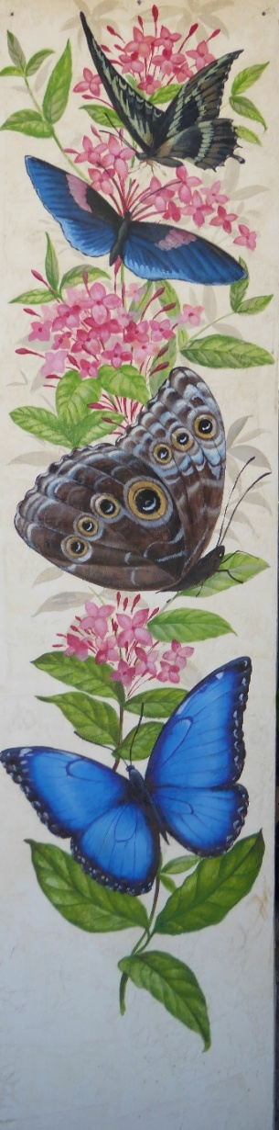
We made an earlier start than usual today because we wanted to view the moth trap and any birds that may come in to eat the moths that remain near the lamp or on the white-sheet below the lamp. We met at 5:30am and after a quick cuppa we walked to the moth-lamp and waited for the birds to arrive which wasn’t for long.

Today we were joined by Cali a local guide and a friend of Roy, he was going to take us later to his local patch.

The first few birds to arrive were Woodcreepers, we saw Plain, Streak-headed and Cocoa, then a pair of White-breasted Wood-Wrens came into view. Over the next hour we had a wonderful time watching many species jumping into the lighted ‘arena’ to catch a moth or two. Some good sightings we made included: Plain Antwren, Tawny-chested Flycatcher, Kentucky Warbler, Olive-striped Flycatcher, Buff-throated Foliage-Gleaner and a host of other species, it was quite a morning.

Breakfast was over by 8am and we were driven down the long access road to the main road, after a couple of kilometers we turned into a side road and followed this up into a valley which rose along the slopes of the ‘Mountain of Silence’.

We began birding on the track and within minutes we saw a good variety of species including several tanagers, also Scarlet-thighed Dacnis, Green Honeycreeper, Paltry Tyrannulet, some flycatchers and many common birds.

We had excellent views of a couple of ‘new’ tanagers, the Black and Yellow is a stunner but so is the Emerald and the Speckled, Bay-headed and the Golden-hooded. A little further along the track we had views of the river below us where we saw Torrent Tyrannulet, Black Phoebe and a small flock of Tawny-crested Tanagers.

Other species were found in the surrounding open meadows and the forest edge on the far bank of the river, we saw Tropical Parula, Black Headed Tityra, Grey-capped Flycatcher, a beautiful Swallowtail Kite flew over and many Oropendolas flew back and forth to their large pendulous nests.

We returned to Rancho at lunchtime, packed our bags and after another nice lunch on the terrace we said goodbye to the staff and to Cali, then we boarded the bus for the journey to Tapanti our next destination. The trip was due to take a couple of hours but we had one scheduled stop at a large lake along the way.

The lake stop proved to be a good move we saw a good number of water birds as we walked along a section of the shore through a mature woodland. The lake is situated in the grounds of a large up-market spa-hotel with open pastures and well attended gardens. We had a great time listing a lot of water birds and a few woodland species. The middle of the lake was littered with rafts of Lesser Scaup whilst the nearer the shore in the masses of water lilies we found Blue-winged Teal, Northern Jacana, Purple Gallinule, American Coot, Neotropic Cormorant, Anhinga and a single Limpkin.

A Snail Kite showed well for us, as did a Keel-billed Toucan, our first Yellow-bellied Elaenia was nice and a small flock of Collared Aracari were an added bonus. Soon it was time to go, we boarded the bus to continue our journey, that took us through some lovely countryside and passed vast fields of sugar cane which was being harvested.

We made a couple of short stops to look at birds, one stop was to watch a Roadside Hawk sitting on the grass-verge next to the road, doing exactly what it says on the tin. We arrived at Kiri Lodge just before dark, we had time to settle in before sitting down to a lovely meal of fresh trout, it couldn’t have been fresher as Kiri Lodge is also a trout farm!

DAY 8 – 26TH FEBRUARY 2015

KIRI LODGE – TAPANTI NATIONAL PARK – REAL MACHO (PRESA TAPANTI)

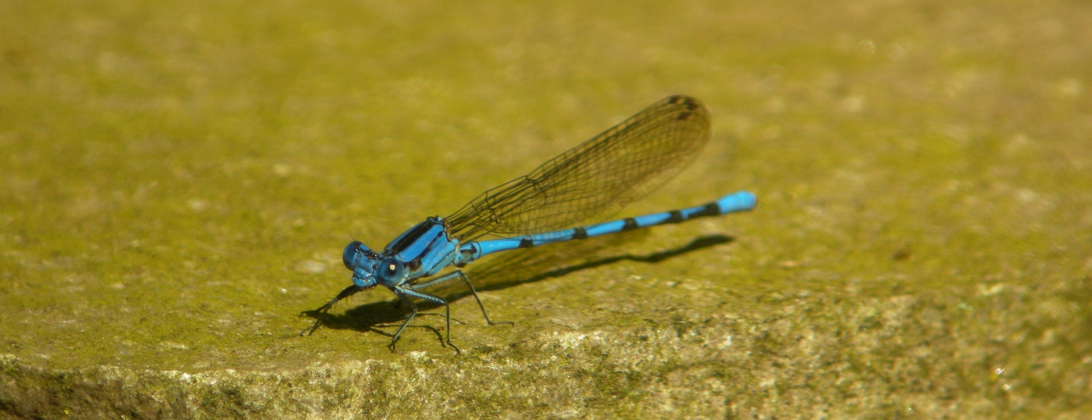
For the last four years it has rained during my visit to Tapanti National Park but not today! We met at 5:30am for the short drive to the park entrance and as it got light we could see a clear sky, perfect weather for birding with no wind. We planned to bird along the approach track to the park for an hour or so then return to the lodge for breakfast and after that return to the park for the rest of the morning.

Our first sighting was of a Broad-winged Hawk, a juvenile sat on a fence-post next to the track, then we found a small
Flock of Yellow-faced Grassquits and a Black Phoebe. We started our walk about a kilometer from the entrance gate, we had dense forest on our left and open pasture to our right, the light was now improving by the minute. A Black Guan showed well for us before we spent some time trying to track down a small party of Black-breasted Wood-Quails, their very loud calls were ringing out from just inside the forest, but alas we never had satisfactory views of them. We met up with mixed flocks of tanagers and added Spangled-cheeked Tanager to our list we also saw Yellow-bellied Flycatcher for the first time. After an hour or so we had quite a list but we had to return to the lodge for breakfast.

At 8:30am we were back in the park, this time we drove several kilometers into the forest before disembarking to begin our walk. Tapanti protects some 300k hectares of mid-elevation primary forest, it has many well marked trails and a central track that cuts through the forest for many kilomerters. Our plan was to walk back towards to entrance and bird along the main track which is exactly what we did.

Our plan worked a treat as we soon realised that there were a lot of avian activity, we bumped into many mixed feeding flocks, several species moved through the canopy feeding together. The mountainous terrain meant that we were either straining our necks looking high up to our right or we could watch at eye-level or below us to our left. We listed a good number of species over the next few hours with some cracking views of some very nice birds.

Emerald Toucanet showed well but briefly and we spent some time tracking down a Spotted Barbtail and then a Red-faced Spinetail. We put some time in watching a pair of Golden-browed Chlorophonia what a stunning looking bird, a few flycatchers went onto the list with the Tufted Flycatcher getting the most admiration. A Scale-headed Pygmy-Tyrannulet showed very well as did Slate-throated Redstart and several American Warblers. Some birds were not so obliging, Silvery-fronted Tapacula never came out, the same happened with Collared Trogan and we only got brief views of Grey-breasted Wood-Wren.

As lunchtime approached the bird movements reduced but we managed to finish on a high when we found the Red-headed Barbet (a female) it sat briefly in the same tree as a Squirrel Cuckoo, this stunning barbet is a must-see Costa Rican gem. Lunch was taken at the lodge and just outside the restaurant we could see a large colony of Montezuma Oropendolas, they were in the process of building their huge hanging nests. We also saw our first Melodious Blackbirds and one lucky person photographed a male Yellow-throated Euphonia.

During lunchtime it clouded over and the light diminished somewhat but we set off to look for new species, this time we drove nearer to the town of Orosi and took a track up into the mountains that led us to a dam with a reservoir behind the dam. On the water we saw 50-60 Lesser Scaup and nothing else so we began our walk back down the track towards Orosi. Birding was very difficult because the light was so bad and the habitat consisted of mature forest with a very high canopy, nevertheless we saw a fair selection of species, lots of tanagers and a few American warblers. Some of the warbler highlights included Golden-winged, Blackburnian, Townsend, Chestnut-sided and Tennessee Warblers.

We popped into Orosi town centre on the way back to the lodge, it was dark by the time we arrived, but we did see a number of Common Pauraque Nighthawks that had settled on the track, a nice species to end the day with.

DAY 9 – 27TH FEBRUARY 2015
KIRI LODGE – TAPANTI NATIONAL PARK – TRANSFER TO SEVEGRE

Another glorious morning at Tapanti, cloudless sky, a little chilly but dry! We drove to the entrance to the park and walked back down the track from where we had come. The birding was slow for a while but it picked up a little, the highlights were: good views of both Speckled and Spangle-cheeked Tanagers and we spent some time trying to coax an Immaculate Antbird into view, it was hard going looking through a small gap in the trees and only a few of the group saw it. Our only other new sighting was of a Brown-capped Vireo.
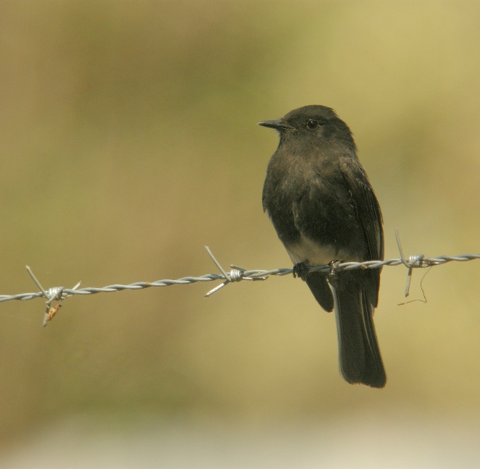
After breakfast we set off for the long drive to our next destination, the Savegre Hotel found high in the ‘Central Cordillera’ mountain range but first we made a stop at Ujarras to look for the White-eared Ground Sparrow. The habitat was not what we expected, instead of open grassland we were taken to large fields of vine-like plants which were producing large Squash Fruits, the vines grew over a lattice work of wires about 2 meters off the ground, below the vines a micro-habitat of ground weeds were supported, this is where we looked for the sparrow.

Unfortunately for us the Ground-Sparrow failed to show but in our endeavour to see one we found Lesser Goldfinch, a great bird for our list, the male was stunning. We also found an Indigo Bunting, not the beautiful male but a drab looking female, Variable Seedeater, Blue-Black Grassquit, Rufous Collared Sparrow and Ruddy Ground-Dove made up some of the supporting cast.

We continued to Savegre after about an hour, our journey took us up into the clouds, this high elevation habitat holds a completely new set of bird species and giving us an exciting prospect of seeing the wonderful Resplendent Quetzal. The journey took over 3 hours because we had to make a long detour as one of the main roads was closed due to a major landslide. So we arrived in the area in time for a late lunch, which was devoured hastily before we began to start birding along this high altitude ridge.

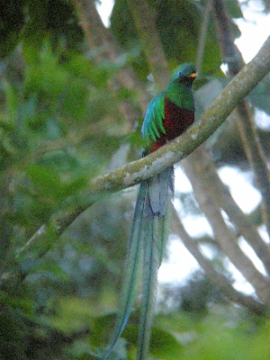
Our birding began around 3:30pm along a wide track along the ridge of the mountain range, it was quite chilly in the clouds and the light varied from good to very bad, a nightmare for photography! However, despite the poor light conditions, we saw many of our target species. Hummingbirds were the highlight with Volcano and Fiery-billed showing well at times, we also saw Scintillant, Magnificent and Green Violetear. Better was to come when we coaxed out a Timberline Wren, then we found Sooty-capped Bush Tanager, Black-capped Flycatcher, Sooty Thrush and best of all Long-tailed Silky-Flycatcher. Wow, it will be hard to follow those sightings, but we did.

Back on the bus we had 13 kilometers to go to reach the hotel, most of this was downhill into the Savegre Valley, it was a very steep and winding road but we made a couple of stops to look at roadside birds. A Sooty Thrush sat on a fence then we found 4 more Long-tailed Silky Flycatchers, followed by Collared Redstart, Black-capped Flycatcher and Band-tailed Pigeons. Another stop produced Large-footed Finch, Flame-coloured Tanager and more Sooty-capped Bush-Tanagers, phew it was smashing birding!

At the bottom of the valley, Johan our guide, knew of a fruiting avocado tree so we pulled over and got out to search for the Quetzal as avocados are its favourite fruit. Within five minutes a beautiful male RESPLENDENT QUETZAL flew into the tree, fantastic, the light was too dull for good photography , but what a super bird.

Well that got the group buzzing as we finished the last few kilometers, guess what bird-of-the-day was? Dinner was taken at 7:30pm then we had a relaxing drink in the lounge as we went through the sightings list.

DAY 10 – 28TH FEBRUARY 2015

FULL DAY AT SAVERGE HOTEL

WEATHER: SUNNY MOST OF THE DAY CLOUD LATER, CHILLY TO START

What a wonder place this is, birds and birders are everywhere, the grounds are lovely and as soon as walk out of the main complex you see even more birds. We met at 6am outside the hotel reception where a number of hummer feeders and a larger bird-table can be found. They were very busy and Johan our guide talked us through the identification of six species of hummingbirds that were regular visitors to the feeders, we saw all six!

The bird table was attracting Acorn Woodpeckers, Flame Coloured Tanagers, Bananaquit and a few common tanager species. The prolific flower beds were regularly visited by the Slaty Flowerpiercer as well as a few American warblers, namely; Wilson’s, Tennessee and Chestnut-sided.

From deep in the woods we heard the call of the Spotted Wood-Quail but saw no sign of one as we walked through the nearest patch of woodland. The first bird we saw was a Resplendent Quetzal, it was nice to see a female, she soon disappeared. Our walk took us through the woods to an open area of grass-lawn and on the edge of the wood Johan showed us the nesting-site of the Quetzal, which was a hole in a dead tree stump, but there was no sign of the birds.

We eventually dragged ourselves away from the Quetzal nest-hole and continued birding in the grounds of next door’s hotel where we found several interesting species including a couple of additions to the list. A Ruddy-capped Nightingale-Thrush posed nicely for us as did the Spangle-cheeked Tanager, we also saw a small flock of Band-tailed Pigeons sitting in the early morning sunlight. A Brown-capped Vireo was a nice species to find, we had good views of Dark Pewee, Summer Tanager, and more American warblers appeared, from a bridge over the river Savegre we saw
a beautiful male Quetzal that sat nearby in full view, the cameras went crazy.
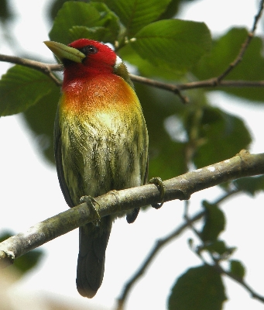
Our walk back to the hotel for breakfast was punctuated with pauses to watch more species the best of which was the Long-tailed Silky-Flycatcher, another stunning species to look at. We ate breakfast and after a short break we boarded a couple of all terrain people-carriers for the journey to the top of the nearest mountain. The journey took about twenty minutes and as we climbed another 500 meters.

It was magical at the top, we stood in primary forest, the sunlight was streaming through and bird song was everywhere. We quickly got our scopes onto a Ruddy Pigeon, then a pair of Acorn Woodpeckers followed by a Yellowish Flycatcher. We walked off the main track onto a woodland trail that snaked its way downward towards a stream. A Collared Restart flitted close by then a Flame-throated Warbler appeared, a stunning male showed really well.

A number warblers showed before we hit a feeding flock of species, it was wonderful to a large number of species in a small area of the forest, the highlights were seeing: Barred Becard, Ruddy Treerunner, Buffy Tuftedcheek, (I’m not making these names up! They are real birds!) also Black-throated Green-Warbler and more Tanagers.

We continued along the trail stopping to look at various species, Grey-brested Wren was a tough cookie, not many of got to see it, the same went for Black-cheeked Warbler and Chestnut-capped Bush Finch but Collared Trogon showed well as did Yellow-thighed Finch and Common Bush-Finch.

The forest trail eventually broke out onto the main track much lower down, we could see open sky again and after just having brief glimpses of Ornate Hawk-Eagle we now had good views of both the common vultures, also Swallowtail Kite, Red-tailed Hawk and large numbers of Collared Swifts. Further down the track we stopped to watch a small flock of Yellow-bellied Siskins and as we did nine Sulphur-winged Parakeets dropped into an apple orchard and started scrumping! We spent some time watching them and also noted Tennessee Warbler, Rose-breasted Grosbeak, Rufous-collared Sparrow, Ruddy-capped Nightingale-Thrush and a couple of Volcano Hummingbirds were bathing in the stream behind us.

Lunch was taken at 1pm and we reconvened at 2:30pm to repeat this morning’s walk through the local woods, we ventured further this time and added a couple of vireos to our list as well as having sightings of Torrent Tyrannulet, Quetzal, Long-tailed Silky-Flycatcher and many more species.

Our last birding excursion was at 5pm as we boarded the bus to drive to the head of the valley to look for owls and nightjars, it was a little disappointing, the owls didn’t show but we had great views of a perched Dusky Nightjar, this regional endemic species is the only nightjar to live above 1800 meters, the views were excellent but brief.

We got back to the hotel at 7pm and went dinner around 7:30pm, this was our last night in this wonderful place, tomorrow we are off to warmer climes and lower altitudes.

DAY 11 – 1ST MARCH 2015

SAVEGRE GROUNDS – TRANSFER TO TALARI WITH STOPS AT THE ‘PARAMO’ AND BOSQUE SE TOLOMUCA

It was quite windy in the night and when we met up at 6am the wind continued and there was a fair amount of cloud. We walked into the woodland next to the hotel complex to search for Wood-Quail without success, the track led us to the Quetzal nest site and both adult birds were on display. Other species on show were the usual tanagers but we did see Chestnut-capped Brush-Finch a new bird for most of the group.

After breakfast we packed our bags, boarded the bus and set off out of the Savegre Valley, we were sorry to leave such a wonderful place. We climbed up out of the valley and headed westward on the main highway the road climbed still further until we reached a height of just over 3000 meters, we were in the clouds as we turned off the road onto a track into the ‘Paramo’, a unique tree-less habitat that rarely sees direct sunlight and is constantly wet, under cloud cover and very windy, and yet, a number of species breed in his hostile environment. The Volcano Junco was our primary target and it took quite a while to find one and even then not all of us saw it, we did find Timberline Wren and a few Sooty-capped Bush-Tanager but that was all. We were glad to leave this cold and wet habitat, we used the heating on in the bus for the first and only time of the trip.
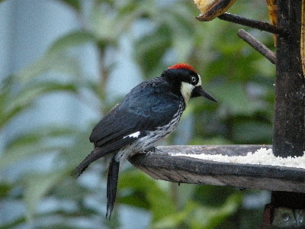
We started to descend, the cloud cover melted away and the temperature rose as we pulled into the car park of a roadside restaurant, a hot chocolate went down a treat. The restaurant had a lot of bird feeders, we had great views of a number of ‘hummers’ including the Fiery-throated Hummingbird, we also watched Sooty Thrush and Large-footed Finch on the lawns below us.

Next we stopped at a small reserve, called Bosque de Tolomuca, a small B&B was established in lovely gardens which also had woodland trails and lots of bird feeders. We listed a number of new ‘hummers’ including the Snowy-bellied Hummingbird, the Green-crowned Brilliant and the Magenta-throated Woodstar. It was a wonderful place, the sun came out and the temperature rose significantly as we ate our picnic lunch on the terrace. Our walk in the woods was very successful, we had some superb sightings of Emerald Toucanet, Elegant Euphonia, an exquisite male, then a stunning male Red-headed Barbet turned up, wow what a great looking species. A supporting cast of Swallow-tailed Kite, Short-tailed Hawk, Cherrie’s Tanager, Baltimore Oriole, Western Wood-Pewee, Paltry Tyrannulet and many common species made up for a great couple of hour’s birding.

Moving on we continued our descent to a level of around 800 meters, we passed through San Isidro and onto the grounds of our lodge for the night at Talari. This superb little lodge sits in secondary woodland and protects just 20 hectares but it is a birding hotspot that has been a regular venue for birding groups for many years. Several regional endemics are regularly recorded, in the past Wingspan Tours have had great results in the grounds.

As soon as we got off the bus we found two Fiery-billed Aracari’s, how cool was that? We then heard another target species calling, we tracked it down to a nearby bush and had great views of an Orange-billed Nightingale-Thrush, superb birding, two great sightings in just five minutes.

After checking in and settling into our rooms we decided to walk during the remaining two hours of daylight. An open area by the swimming pool overlooked a river and an area of dry forest we had a productive hour standing there with a number of sightings: Red-crowned Woodpecker, Dusky-capped Flycatcher, Common Tody-Flycatcher, Buff-throated Saltator, Green Honeycreeper, Red-legged Honeycreeper, Cherrie’s Tanager and lots more.

Our walk finished in the dining room of the lodge, this huge open-plan ‘platform’ had wonderful panoramic views over the gardens which fell away along the slope. A Riverside Wren was a super find as was a Yellow-crowned Euphonia. Scaled Pigeon was a brief sighting for some of us as we all searched for a White-crested Coquette and the elusive Turquoise Cotinga, but all our efforts went unrewarded.

Dinner was served at 7am which went down well with a couple of cold beers, we were finished by 8pm so most of us went off to bed.

DAY 12 – 2ND MARCH 2015

TRANSFER: KIRI LODGE TO LOS CERROS LODGE WITH STOPS AT LOS CUSINGOS – QUEPOS RICE FIELDS AND QUEPOS BAY

We met at 6am for another walk around the gardens and woodland at Talari Lodge, we had a clear sky, light winds and a very warm temperature which stayed with us all day.

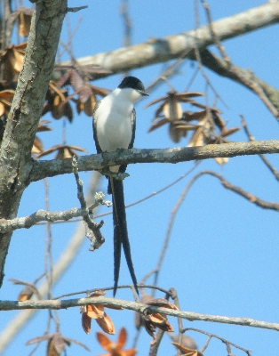
In the open area near the swimming pool we watched Red-crested Woodpeckers flit from tree to tree where several other species appeared, in fact there was a lot of activity. We found our first Tropical Gnatcatcher, we admired a beautiful Blue-crowned Motmot and several Grey-headed Chachalaca fed high up in the canopy, where several other species we feeding on fruit. A male Rose-breasted Grosbeak showed well next to a Buff-throated Saltator in the canopy with a variety of tanagers. A Streaked Flycatcher was new for is too, a striking bird doing what flycatchers do and a Long-billed Starthroat, a new ‘hummer’ for our list, sat and posed for us.

Breakfast was served at 7am but was interrupted several times when sightings were made of birds on the feeders or in nearby trees, we heard a Streaked Saltator and Roy our guide managed to see it but none of the group did. A Yellow-crowned Euphonia appeared on the feeder with the two varieties of Honeycreepers, both stunning species. Scaled Pigeons could be heard and some of the group saw a couple briefly just before we finished our meal.

We were on the road by 8:15am heading for the reserve at Los Cusingos, a small forested reserve founded by Alexander Skutch, the famous American author and ornithologist who put Costa Rica on the ‘birding’ map. A scheduled stop was made in an area with open pastures and scattered trees hoping for a sighting of a Pearl Kite, we found White-tailed Kite, Swallow-tailed Kite but not the Pearl variety. A few Forked-tailed Flycatchers were nice to see and the Smooth-billed Ani was a good find.
At Los Cusingos we explored the gardens around Alexander Skutch’s home, which is now kept as a museum in his honour, he died in 2004 just before his 100th birthday. The forest around the garden is supposed to be a good place to find White-crested Coquette, Fiery-billed Aracari and Turquoise Cotinga, we have seen all three of them in the past but none of them showed up today.

We took one trail into the forest for a walk that lasted an hour or so, birds were few and far between, it was only 10am but the temperature was up in the 30’s and the humidity was high too. After a while we made a series of finds, all which were new for us, Blue-crowned Manikin was nice but elusive, a Rufous Phia sat nicely for us then we found a couple of Red-capped Manakins, they were performing their ‘moon-walk’ display high above us. On the last leg of the walk we found a Golden-crowned Spadebill another nice addition to our collection.

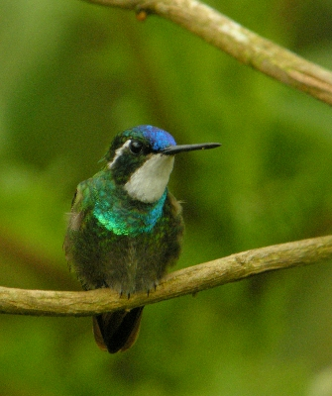
From Los Cusingos we hit the road and spent an uninterrupted couple of hours driving to the Pacific ‘Southern’ region near Quepos. A nice lunch break was made at a little roadside restaurant where the food was excellent then we drove a short distance to our next birding venue about 10km south of Quepos. The landscape had now changed from forested hills and mountains to very flat meadows and rice fields. There was also kilometer after kilometer of Oil-Palm plantations, a very mono-cultured environment with scant biodiversity, the thick palm canopy blocked any light from reaching the ground, leaving a very lifeless ground level.

We drove through one such plantation to find open rice fields and cow pastures beyond, a water channel ran along the edge of the Palms with an avenue of mature trees running into the distance, this is where we directed our birding efforts. It was an amazing contrast to the Oil-Palm environment, wildlife was prolific, as well as over 30 species of birds we listed several mammals, reptiles, interesting insects and plants.

The meadows held large numbers of Cattle and Great Egrets, we also saw Wood Stork, Black Hawks and large flocks of grackles, cowbirds and seedeaters. Along the water-channel we found several open pools with Green Iguanas, Green Basilisk Lizards and a variety of birds including the American Pygmy Kingfisher. In the avenue of trees and bushes a good number of warblers were found feeding alongside other species such as orioles, buntings, flycatchers and tanagers. We found a number of the beautiful Indigo Buntings as well as American Redstart, Northern Waterthrush, Black-striped Sparrow, White-collared Seedeaters and we got a glimpse of a fly-by Pearl Kite. A Swainson’s Hawk circled above as Collared Swifts, Barn Swallows and many vultures filled the sky. It was a terrific birding stop and as we left the area we stopped to look at Squirrel Monkeys and White-faced Caphuchins.

We continued our northward journey along the pacific coastline making a quick stop at Quepos where we listed Magnificent Frigatebird, Brown Pelican, Laughing Dove and not much else. So we pressed on and arrived at our new lodge around 7pm, it had been a long day, we listed some great new species, a nice cold beer went down a treat!

DAY 13 – 3RD MARCH 2015

Morning at Carara National Park - afternoon boat cruise on the Rio Tarcoles

CARARA NATIONAL PARK - RIVER CRUISE ON THE TARCOLES
WEATHER: DRY SUNNY, WARM WITH A NICE BREEZE.
We had a day of two completely contrasting halves: the morning birding was a walk through tropical rainforest where birds were hard to see and find, then in the afternoon we cruised on the river Tarcoles where birds we easily seen and easy to locate. Some of the group decided to have the morning 'off ' to relax back at the lodge, they sat by the pool, or went swimming and joined us later at lunchtime, whilst the majority of the group left at 7am, after an early breakfast, heading for Carara to be in the park by 7:30am just at it opened.
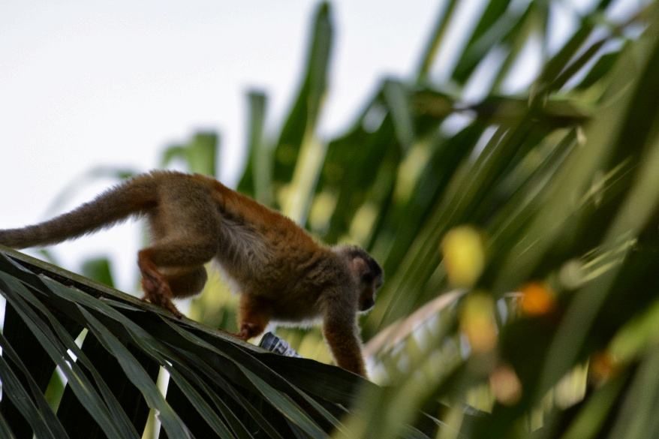
It was quite hard going in the forest, birds were few and far between but there was plenty of other wildlife to be seen, not just birds! Roy showed us the white Ghost Bat which sits clinging to the underside of the leaves of the banana plants, we also continued to see large numbers of the GREEN PAGE MOTH or GREEN URANIA (Urania fulgens) this very colourful green and black moth resembles very closely a swallowtail butterfly and has an extraordinary life and migration cycle.[Every 4 to 8 years, local populations will relocate en-masse to from one region to another. The spectacular migration is stimulated by the relationship this moth has to its host plant, the Liana (Omphalea sp.). This plant contains poisons to discourage animals from eating it. The green page moth caterpillar can tolerate this without dying, and these toxins are absorbed to help protect the caterpillar from predators. Over a few years, though, the Liana slowly increases the level of its toxins until the plant becomes too toxic for the caterpillars to eat, adult moths then begin a migration to a region where the Omphalea has a lower toxicity, this is usually an east-west and vice versa pathway. They leave in July or August and travel for several months. The following March, the moths will return to where their population began, we witnessed this migration as hundreds of moths trickled overhead all-day and every day, we often encountered gathered masses on flowering Lianas just as evening roosting began,
We also found a Fer-de-lance Snake ( Bothrops asper), this infamous viper’s high venom production and toxicity are paired with an active and edgy disposition, making it one of the most dangerous creatures one can encounter in Costa Rica. It is the most dangerous snake in Central America and causes the most snakebite-related deaths among humans in Costa Rica, so we gave it a lot of respect and took photographs from a safe distance!
Other wildlife seen was; Nine-banded Armadillo, White-faced Capuchin, Mantled-Howler Monkey, Spiny-tailed Iguana and Variegated Squirrel and about 30 species of birds, the best sightings of which were of Scarlet Macaw, encountered several times as noisy fly-overs, none were seen perched, Royal Flycatcher at its nest, also Dot-winged Antwren, Long-billed Gnatcatcher, Barred Antshrike, White-whiskered Puffbird and Orange-collared Manakin.
At lunchtime the bus picked us up at the entrance to the trail, the rest of the group were already onboard so we all went to lunch together at a tiny restaurant on the beach near Tarcoles. We then drove down to the mouth of the river where a number of companies offer river boat cruises, our cruise was booked for 2pm.
We had a marvelous relaxing time, nearly 3 hours of fantastic bird and wildlife watching, we saw just under 50 species of birds, amazing really. The trip took us upriver for a hour where large American Crocodiles sat on the muddy banks or drifted ominously by like floating logs. We saw the Turquoise-crowned Motmot at its nest site - which is a hole in the river bank just like the Kingfishers.
A host of herons and egrets, ibis, storks, spoonbills, waders, cormorants, frigatebirds, raptors and passerines made this trip so memorable. The weather was perfect too, lovely sunshine, no wind just a lovely cooling breeze, the sunset was magical.
For the last hour or so we drifted into mangrove forest where narrow channels allowed us to get very close to a number of bird species, the American Pygmy Kingfisher sat motionless for us whilst Prothonatory Warbler and Mangrove Warbler (the red-headed version of Yellow Warbler) also showed well. Several Red-winged Blackbirds dashed by, a number of Ospreys sat perched as did Common Black-Hawk and a couple of Plumbeous Kites circled overhead.
All in all we had a smashing trip, feedback from the group suggested that this was the tour highlight so far! We arrived back at the lodge in the dark around 6pm. A nice cold drink was enjoyed during a lovely dinner.
DAY 14 – 4TH MARCH 2015

TRANSFER FROM CERROS LODGE TO ENSENADA LODGE WITH STOPS AT CHOMES SHRIMP FARMS AND CALDERA

Our early morning walk began at 6am, it was another beautiful morning clear blue sky, light winds and a lovely temperature. Cerros Lodge sits on the backbone of a large peninsula that juts out into the Pacific Ocean with panoramic views northward into the Southern section of Nicoya Bay and down over the river Tarcoles to the south.
We walked along the central track which drops down to sea level over a kilometer or so, but from our vantage point of 200 meters higher the view was terrific, it wasn’t long before we bumped into lots of feeding birds. Flycatchers were everywhere, we watched a couple of larger species, the Streaked and Nutting’s Flycatchers, as well as recording our first Rose-throated Becard. Roy heard a Striped Cuckoo but we couldn’t locate it then a Ferruginous Pygmy Owl showed well along with many other common species.

Further along the track we watched Striped-headed Sparrow and a pair of beautiful Black-throated Trogons and a single Violaceous Trogon, lots of Hoffman’s Woodpeckers searched the treetops for food whilst Scrub Euphonia and Orange-fronted Parakeets fed on fruit, several sightings were made of the huge and brightly coloured Scarlet Macaws, they looked exquisite in the morning light, how nice to see this species free-flying and not in a cage in a European “Bird World”.

Packing and breakfast was completed by 8:15am and we were on the road soon after, we popped into Tarcoles for a couple of shopping chores and in doing so the group found the first Lineated Woodpecker of the tour. Our journey then took us northward on the main Pan-American Highway. We made a stop at Caldera where a bridge spans a large inlet and where groups of birds either feed or roost on the surrounding sand-bars. Hundreds of Laughing Gulls were joined by Brown Pelicans, Royal Terns and a few waders. Not far from there we turned off the highway onto a side road which ran along a mangrove swamp and that is where we spent some time looking for new species.

A Panama Flycatcher was seen well by all of us, we also found lots of Yellow Warblers of the subspecies Erythachroides, which is often called the Mangrove Warbler, the male has a beautiful reddish-brown head-colour. Other species seen included; Osprey and a fly-over Short-tailed Hawk.

Moving further north we drove for an hour or so before we turned eastward onto a track that led us to the coast and a large Shrimp Farm at Chomes. A large number of pools held varying amounts of water and supports many birds especially during high tide periods. We arrived during a low tide period but nevertheless there was a good number of birds roosting or feeding, we found several new species, a Black Skimmer sat with a number of Black-bellied Plovers, Least Sandpipers and Black-necked Stilts. Elsewhere we found a flock of Marbled Godwits, Western Sandpiper, Stilt Sandpiper, Whimbrel and a single Lesser Scaup.

Further exploration uncovered more pools where over 2000 Blue-winged Teal roosted, we picked out a couple of Northern Shoveler within the ranks of the teal, a Blue Grosbeak appeared in a pool-side bush. More waders, egrets, herons and ibis sightings added to our enjoyment, a Long-billed Curlew, Caspian Tern and more of the common waders were found a little later just before we left.

The final leg of the journey was along dirt roads across agricultural farmland and open woodland, we stopped a few times to look at more pools, mangrove swamps and perched raptors. We saw Common Black-Hawk and our first Yellow-naped Parrots before arriving at Ensenada Lodge just as the sun went down.

Ensenada Lodge is situated on the mainland coast of Nicoya Bay, the accommodation faces the bay giving wonderful panoramic views of the gardens and coastline. The sunsets from here are magical, we arrived just in time to see one before we got ready for dinner in the spacious open-plan restaurant. Our bird log total now exceeded 400 species with still more to come tomorrow! Another owl sighting was made by the few who stayed up after 10pm, a Pacific Screech-Owl showed well in excellent full-moon light.

DAY 15 – 5TH MARCH 2015

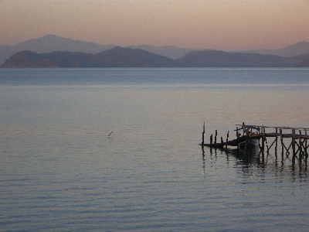
ENSENADA ALL DAY

Ensenada is a unique place it combines three seemingly paradoxical roles, it is a Wildlife Refuge, a working Farm and a private hotel with 22 cabins spaced in well-manicured gardens and yet it appears to work well as the bird list alone is extremely impressive, we also saw Howler Monkeys along the approach track and a Mexican Tree-Porcupine during dinner last night. The habitat is essentially dry forest with pastures, salt-pans, mangrove swamp, lagunas, shoreline and the gardens.

We met up at 6am, the weather was wonderful, a clear blue sky, no wind and lovely light, a quick look out into the Nicoya Bay from the gardens produced a number of sightings, Magnificent Frigatebirds were ever present, drifting high up on the thermals, you hardly ever see them flap their wings! Brown Pelicans likewise, we also saw large numbers of Laughing Gulls, Royal Terns, a single American Herring Gull and a few Ruddy Turnstones.

We then walked through the hotel compound where White-throated Magpie-Jays abound and Yellow-naped and White-fronted Parrots scream overhead from the canopy of the fruiting trees. We saw a pair of Turquoise-browed Motmots, our first Spot-breasted and Streak-backed Orioles as well as the more common Baltimore Orioles. A Ferruginous Pygmy-Owl showed well but was harassed by the grackles and Kisskadees and we noted several flycatcher species.

After breakfast we departed on the bus for the short ride to ‘salinas’ or salt-pans, we all jumped out of the bus when a call of ‘Laughing Falcon’ went up; this stunning raptor posed well for the cameras and was left undisturbed after we had had our fill. We then decided to walk the remainder of the track to the pans, the heat of the day was already being felt even at just 9am!

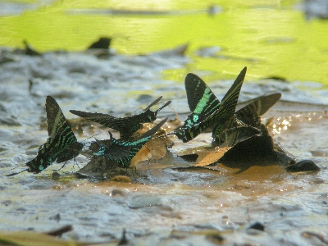
We found White-lored Gnatcatcher, Nutting’s and Brown-crested Flycatchers, also a couple of us saw Orchard Oriole. We then found Rose-throated Becard, it was a male and looked so different from the female we had seen earlier that most of group thought it was another species, Roy stepped in to put us right. We also saw a Yellow-Olive Flycatcher and two new Hummingbird species; Canivet’s Hummingbird and Plain-capped Starthroat.

The salt-pans were a disappointment, they are usually frequented by many waders, herons and egrets, but today there was a lot of activity by work-men and the tide was low so we only saw a few species. So we concentrated on the mangroves and the open scrub found a little further along the track. The Mangrove Vireo refused to be lured out of the dense foliage but we did see Yellow-throated Vireo, lots of Yellow Warblers, a Streak-headed Woodcreeper and a Northern Waterthrush. In the scrub area we found our prized sighting after Roy heard it call. It was the LESSER GROUND-CUCKOO, this highly sought-after species showed extremely well for us, what a great find. A small lake provided sightings of Tricoloured Heron, Black-necked Stilts, Least Sandpiper but not much else.

We returned to the lodge at 11am it was getting really hot, 37C was recorded by some of the group, a long lunch was extended to all afternoon by some of the group, but a few of us braved the heat at 2:30pm as we set off into the dry forest area. We noted Orange-chinned, White-fronted Parrots and a Ferruginous Pygmy Owl along the way and to our great delight we found a Double-striped Thick-Knee, this bird appeared to be sitting on eggs so we kept our distance.

The forest walk didn’t produce much, a Squirrel Cuckoo showed well as did White-lored Gnatcatcher and several flycatchers, one person had good views of a Northern-beardless Tyrannulet. The last part of the walk produced a couple of nice sightings, a Banded Wren showed for a brief moment whilst a White-necked Puffbird posed on a vine and let us approach without flinching!

Back at the lodge we learned that some of the group had seen Crested Bobwhite so we went down to a nearby pool to look for them. We had no luck with the Bobwhites but we did see our first Solitary Sandpiper.

Finally some of us went to the look-out point to watch the setting sun and to scan the large number of birds roosting on the jetty. Hundreds of Royal Terns were vying for space with Laughing Gulls, Sandwich Terns and Ruddy Turnstones, a few Brown Pelicans took the best positions. Below the jetty and all along the shoreline hundreds of Semipalmated Sandpipers jostled for spaces, there must have 10 to a square meter, the odd Western Sandpipe could be seen with them.

Well that concluded our last day’s birding, we have a couple of hours free in the morning before we set off for the airport so our very last birding excursion will be made then.

DAY 16 – 6TH MARCH 2015

ENSENADA LODGE - TRANSFER TO SAN JOSE

Our very last day started the same as yesterday including the hot, dry weather. We met at 6am and went straight down to the pool to look for Bobwhites, only Roy our guide managed to see them, however during our 1 hour walk we notched up easily 25 species. Birds seen at the pool included; Solitary Sandpiper, Green Heron, Northern Waterthrush, Social Flycatcher and several other common species.
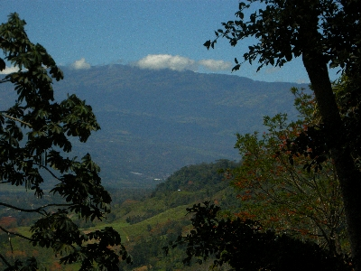
At breakfast we had to fight off the Magpie-Jays as they came down to steal things from our plates. Just after breakfast one couple, Roy and Winnie, went back to the pool and found the Crested Bobwhites!

By 9am we were packed and ready to board the bus, we left at 9:15am and by 11:45am we were all safely back at the airport. The trip was finally over, the group dispersed in the departure terminal heading off in different directions to catch flights home at different times.

SPECIES RECORDED DURING 2014 & 2015

A = 2014
B = 2015
H = heard only
L.O. = Leader only

 | ENGLISH NAME | SCIENTIFIC NAME | A | B
 | Tinamidae
 | Great Tinamou | Tinamus majorO | √ | √
 | Anatidae
 | Black-bellied Whistling-Duck | Dendrocygna autumnalis | √ | √
 | Muscovy Duck | Cairina moschata | √ | √
 | Blue-winged Teal | Anas discors | √ | √
 | Northern Shoveler | Anas clypeata | √ | √
 | Lesser Scaup | Aythya affinis | √ | √
 | Cracidae
 | Gray-headed Chachalaca | Ortalis cinereiceps | √ | √
 | Crested Guan | Penelope purpurascens | √ | √
 | Black Guan | Chamaepetes unicolor | √ | √
 | Great Curassow | Crax rubra | √ | √
 | Podicepedidae
 | Least Grebe | Tachybaptus dominicus | √ | √
 | Pied-billed Grebe | Podilymbus podiceps | √
 | Odontophoridae
 | Spotted Wood-Quail | Odontophorus guttatus | √ | H
 | Ciconiidae
 | Jabiru | Jabiru mycteria | √
 | Wood Stork | Mycteria americana | √ | √
 | Fregatidae
 | Magnificent Frigatebird | Fregata magnificens | √ | √
 | Phalacrocoracidae
 | Neotropic Cormorant | Phalacrocorax brasilianus | √ | √
 | Anhingidae
 | Anhinga | Anhinga anhinga | √ | √
 | Pelecanidae
 | Brown Pelican | Pelecanus occidentalis | √ | √
 | Ardeidae
 | Bare-throated Tiger Heron | Tigrisomo mexicanum | √ | √
 | Fasciated Tiger Heron | Trigrisoma fasciatum | √ | √
 | Great Blue Heron | Ardea herodias | √ | √
 | Great Egret | Ardea alba | √ | √
 | Snowy Egret | Egretta thula | √ | √
 | Little Blue Heron | Egretta caerulea | √ | √
 | Tricoloured Heron | Egretta tricolour | √ | √
 | Cattle Egret | Bubulcus ibis | √ | √
 | Green Heron | Butorides virescens | √ | √
 | Black-crowned Night Heron | Nycticorax nycticorax | √ | √
 | Yellow-crowned Night Heron | Cochlearius cochlearius | √ | √
 | Boat-billed Heron | Cochlearius cochlearius | √ | √
 | Threskiornithidae
 | White Ibis | Eudocimus albus | √ | √
 | Green Ibis | Mesembrinibis cayennensis | √ | √
 | Roseate Spoonbill | Platalea ajaja | √ | √
 | Cathartidae
 | Black Vulture | Coragyps atratus | √ | √
 | Turkey Vulture | Cathartes aura | √ | √
 | King Vulture | Sarcoramphus papa | √ | √
 | Pandionidae
 | Osprey | Pandion haliaetus | √ | √
 | Accipitridae
 | Gray-headed Hawk | Leptodon cayanensis |  | √
 | Common Black Hawk | Buteogallus urubitinga | √ | √
 | Hook-billed Kite | Chondrohierax uncinatus | √
 | Swallow-tailed Kite | Elanoides forficatus | √ | √
 | Pearl Kite | Gampsonyx swainsonii |  | √
 | White-tailed Kite | Elanus leucurus | √ | √
 | Snail Kite | Rostrhamus sociabilis | √ | √
 | Double-toothed Kite | Harpagus bidentatus | √ | √
 | Plumbeous Kite | Ictinia plumbea | √ | √
 | Barred Hawk | Morphnarchus princeps | √
 | Bicolored Hawk | Accipitor bicolor | √ | √
 | Cooper’s Hawk | Accipitor cooperi | √
 | Crane Hawk | Geranospiza caerulescens | √ | √
 | Harris's Hawk | Parabuteo unicinctus | √
 | White Hawk | Pseudastur albucollis | √ | √
 | Roadside Hawk | Buteo magnirostris | √ | √
 | Broad-winged Hawk | Buteo platypterus | √ | √
 | Gray-lined Hawk | Buteo nitidusO | √
 | Grey Hawk | Buteo plagiatus |  | √
 | Short-tailed Hawk | Buteo bracyurus | √ | √
 | Swainson's Hawk | Buteo swainsoniR | √ | √
 | Red-tailed Hawk | Buteo jamaicensis | √ | √
 | Ornate Hawk-Eagle | Spizaetus ornatus |  | √
 | Eurypygidae
 | Sunbittern | Eurypyga helias | √ | √
 | Rallidae
 | White-throated Crake | Laterallus albigularis | H | H
 | Uniform Crake | Amaurolimnas concolor |  | H
 | Grey-necked Wood-Rail | Aramides cajaneus | √ | √
 | Purple Gallinule | Porphyrio martinicus | √ | √
 | American Coot | Fulica americana |  | √
 | Aramidae
 | Limpkin | Aramus guarauna | √ | √
 | Burhinidae
 | Double-striped Thick-Knee | Burhinus bistriatus | √ | √
 | Charadriidae
 | Southern Lapwing | Vanellus chilensis | √ | √
 | Black-bellied Plover | Pluvialis squatarola | √ | √
 | American Golden Plover | Pluvialis dominica | √
 | Semipalmated Plover | Charadrius semipalmatus | √ | √
 | Killdeer | Charadius vociferus |  | √
 | Recurvirostridae
 | Black-necked Stilt | Himantopus mexicanus | √ | √
 | Jacanidae
 | Northern Jacana | Jacana spinosa | √ | √
 | Scolopacidae
 | Spotted Sandpiper | Actitis macularius | √ | √
 | Solitary Sandpiper | Tringa solitaria | √ | √
 | Ruddy Turnstone | Arenaria interpresjū | √ | √
 | Semipalmated Sandpiper | Calidris pusilla |  | √
 | Willet | Tringa semipalmata | √ | √
 | Greater Yellowlegs | Tringa melanoleuca | √
 | Lesser Yellowlegs | Tringa flavipes | √ | √
 | Whimbrel | Numenius phaeopus | √ | √
 | Long-billed Curlew | Numenius americanus |  | √
 | Marbled Godwit | Limos Fedoa | √ | √
 | Sanderling | Calidris alba | √ | √
 | Western Sandpiper | Calidris mauri | √ | √
 | Least Sandpiper | Calidris minutilla | √ | √
 | Stilt Sandpiper | Calidris himantopus | √ | √
 | Short-billed Dowitcher | Limnodromus griseus | √
 | Wilson’s Phalarope | Phalaropus tricolor | √
 | Laridae
 | American Herring Gull | Larus argentatus |  | √
 | Laughing Gull | Leucophaeus atricilla | √ | √
 | Royal Tern | Thalasseus maximus | √ | √
 | Sandwich Tern | Thalasseus sandvicensis | √ | √
 | Caspian Tern | Hydroprogne caspia | √ | √
 | Rynchopidae
 | Black Skimmer | Rynchops niger |  | √
 | Columbidae
 | Rock Pigeon | Columba livia | √ | √
 | Pale-vented Pigeon | Patagioenas cayennensis | √ | √
 | Scaled Pigeon | Patagioenas speciosa | √ | √
 | Red-billed Pigeon | Patagioenas flavirostris | √ | √
 | Band-tailed Pigeon | Patagioenas fasciata | √ | √
 | Ruddy Pigeon | Patagioenas subvinacea | √ | √
 | Short-billed Pigeon | Patagioenas nigrirostris | √ | √
 | White-winged Dove | Zenaida asiatica | √ | √
 | Olive-backed Quail-Dove | Geotrygon veraguensis |  | √
 | Inca Dove | Columbina inca | √ | √
 | Common Ground-Dove | Columbina passerina | √ | √
 | Plain-breasted Ground-Dove | Columbina minuta | √
 | Ruddy Ground-Dove | Columbina talpacoti | √ | √
 | White-tipped Dove | Leptotila verreauxi | √ | √
 | Gray-chested Dove | Leptotila cassinii | √ | √
 | Ruddy Quail-Dove | Geotrygon montana | √
 | Cuculidae
 | Squirrel Cuckoo | Piaya cayana | √ | √
 | Lesser Ground-Cuckoo | Morococcyx erythropygus | √ | √
 | Groove-billed Ani | Crotophaga sulcirostris | √ | √
 | Smooth-billed Ani | Crotophaga ani |  | √
 | Strigidae
 | Tropical Screech-Owl | Megascops choliba |  | √
 | Pacific Screech Owl | Megascops cooperi | √ | √
 | Vermiculated Screech-Owl | Megascops guatelmalae |  | √
 | Spectacled Owl | Pulsatrix perspicillata | √ | √
 | Mottled Owl | Ciccaba virgata | H | √
 | Ferruginous Pygmy-Owl | Glaucidium brasilianum | √ | √
 | Caprimulgidae
 | Lesser Nighthawk | Chordeiles acutipennis | √
 | Common Pauraque | Nyctidromus albicollis | √ | √
 | Rufus Nightjar | Caprimulgus rufus | √
 | Dusky Nightjar | Caprimulgus saturatus |  | √
 | Nyctibiidae
 | Great Potoo | Nyctibus grandis | √ | √
 | Apodidae
 | White-chinned Swift | Cypseloides cryptus |  | √
 | White-collared Swift | Streptoprocne zonaris | √ | √
 | Black Swift | Cypseloides niger | √ | √
 | Vaux's Swift | Chaetura vauxi | √ | √
 | Lesser Swallow-tailed Swift | Panyptila cayennensis | √ | √
 | Gray-rumped Swift | Chaetura cinereiventris | √ | √
 | Trochilidae
 | White-necked Jacobin | Florisuga mellivora | √ | √
 | Band-tailed Barbthroat | Threnetes ruckeri | √ | √
 | Green Hermit | Phaethornis guy | √ | √
 | Long-billed Hermit | Phaethornis longirostris | √ | √
 | Stripe-throated Hermit | Phaethornis striigularis | √ | √
 | Green-fronted Lancebill | Doryfera ludovicae | √
 | Brown Violetear | Colibri delphinae | √ | √
 | Green Violetear | Colibri thalassinus | √ | √
 | Purple-crowned Fairy | Heliothryx barroti | √ | √
 | Green-breasted Mango | Anthracothorax prevostii | √ | √
 | Green Thorntail | Discosura conversii | √ | √
 | Black-crested Coquette | Lophornis helenae | √ | √
 | Green-crowned Brilliant | Heliodoxa jacula | √ | √
 | Magnificent Hummingbird | Eugenes fulgens | √ | √
 | Fiery-throated Hummingbird | Panterpe insignis | √ | √
 | Long-billed Starthroat | Heliomaster longirostris | √ | √
 | Plain-capped Starthroat | Heliomaster constantii | √ | √
 | White-bellied Mountain-gem | Lampornis hemileucus | √ | √
 | White-throated Mountain-gem | Lampornis castaneoventris | √ | √
 | Purple-throated Mountain-gem | Lampornis calolaema | √ | √
 | Magenta-throated WordStar | Calliphlox bryantae | √ | √
 | Ruby-throated Hummingbird | Archilochus colubris | √ | √
 | Volcano Hummingbird | Selasphorus flammula | √ | √
 | Scintillant Hummingbird | Selasphorus scintilla | √ | √
 | Canivet’s Emerald | Chlorostilbon canivetii | √ | √
 | Violet-headed Hummingbird | Klais guimeti | √ | √
 | Scaly-breasted Hummingbird | Phaeochroa cuvierii | √ | √
 | Violet Sabrewing | Campylopterus hemileucurus | √ | √
 | Stripe-tailed Hummingbird | Eupherusa eximia | √ | √
 | Black-bellied Hummingbird | Eupherusa nigriventris | √
 | White-tailed Emerald | Elvira chionura | √
 | Coppery-headed Emerald | Elvira cuprelceps | √ | √
 | Snowcap | Microchera albocoronata | √ | √
 | Bronze-tailed Plumeleteer | Chalybura urochrysia | √ | √
 | Violet-crowned Woodnymph | Thalurania colombica | √ | √
 | Blue-chested Hummingbird | Amazilia amabilis |  | √
 | Charming Hummingbird | Amazilia decora | √ | √
 | Mangrove Hummingbird | Amazilia boucardi | √
 | Steely-vented Hummingbird | Amazilia saucerrottei | √ | √
 | Snowy-bellied Hummingbird | Amazillia edward | √ | √
 | Rufous-tailed Hummingbird | Amazilia tzacatl | √ | √
 | Cinnamon Hummingbird | Amazilia rutila | √ | √
 | Blue-throated Goldentail | Hylocharis eliciae | √ | √
 | Trogonidae
 | Slaty-tailed Trogon | Trogon massena | √ | √
 | Black-headed Trogon | Trogon melanocephalus | √ | √
 | Baird's Trogon | Trogon bairdii | √
 | Violaceous Trogon | Trogon violaceus | √ | √
 | Black-throated Trogon | Trogon rufus | √ | √
 | Collared Trogon | Trogon collaris | √ | √
 | Orange-bellied Trogon | Trogon aurantiiventris | √ | √
 | Lattice-tailed Trogon | Trogon clathratus |  | √
 | Resplendent Quetzal | Pharomachrus mocinno | √ | √
 | Momotidae
 | Blue-crowned Motmot | Momotus momota | √ | √
 | Rufous Motmot | Baryphthengus martii | √ | √
 | Broad-billed Motmot | Electron platyrhynchum | √ | √
 | Turquoise-browed Motmot | Eumomota superciliosa | √ | √
 | Alcedinidae
 | Belted Kingfisher | Megaceryle alcyon | √
 | Ringed Kingfisher | Megaceryle torquatus | √ | √
 | Amazon Kingfisher | Chloroceryle amazona | √ | √
 | Green Kingfisher | Chloroceryle americana | √ | √
 | American Pygmy Kingfisher | Chloroceryle aenea | √ | √
 | Bucconidae
 | White-necked Puffbird | Notharchus macrorhynchos |  | √
 | White-whiskered Puffbird | Malacoptila panamensis | √ | √
 | Galbulidae
 | Rufous-tailed Jacamar | Galbula ruficauda | √ | √
 | Semnornithidae
 | Prong-billed Barbet | Semnornis frantzii | √ | √
 | Red-headed Barbet | Eubucco bourclerii | √ | √
 | Ramphastidae
 | Emerald Toucanet | Aulacorhynchus prasinus | √ | √
 | Collared Aracari | Pteroglossus torquatus | √ | √
 | Fiery-billed Aracari | Pteroglossus frantzii | √ | √
 | Keel-billed Toucan | Ramphastos sulfuratus | √ | √
 | Black-mandibled Toucan | Ramphastos ambiguus | √ | √
 | Picidae
 | Acorn Woodpecker | Melanerpes formicivorus | √ | √
 | Golden-naped Woodpecker | Melanerpes chrysauchen | √
 | Black-cheeked Woodpecker | Melanerpes pucherani | √ | √
 | Red-crowned Woodpecker | Melanerpes rubricapillus | √ | √
 | Hoffmann's Woodpecker | Melanerpes hoffmannii | √ | √
 | Smokey-brown Woodpecker | Picoides fumigatus | √
 | Hairy Woodpecker | Picoides villosus | √
 | Rufous-winged Woodpecker | Piculus simplex | √ | √
 | Golden-olive Woodpecker | Collapses rubiginosus | √ | √
 | Cinnamon Woodpecker | Celeus loricatus | √
 | Chestnut-colored Woodpecker | Celeus castaneus | √
 | Lineated Woodpecker | Dryocopus lineatus | √ | √
 | Pale-billed Woodpecker | Campephilus guatemalensis | √ | √
 | Falconidae
 | Crested Caracara | Caracara cheriway | √ | √
 | Yellow-headed Caracara | Milvago chimachima | √ | √
 | Laughing Falcon | Herpetotheres cachinnans | √ | √
 | American Kestrel | Falco sparverius | √ | √
 | Bat Falcon | Falco rufigularis | √ | √
 | Psittacidae
 | Crimson-fronted Parakeet | Aratinga finschi | √ | √
 | Sulphur-winged Parakeet | Pyrrhura hoffmanni | √ | √
 | Orange-fronted Parakeet | Aratinga canicularisR | √ | √
 | Great Green Macaw | Ara ambiguus | √ | √
 | Scarlet Macaw | Ara macao | √ | √
 | Orange-chinned Parakeet | Brotogeris jugularis | √ | √
 | White-crowned Parrot | Pionus senilis | √ | √
 | White-fronted Parrot | Amazona albifrons | √ | √
 | Red-lored Parrot | Amazona autumnalis | √ | √
 | Mealy Parrot | Amazona farinosa | √ | √
 | Yellow-naped Parrot | Amazona auropalliata | √ | √
 | Thamnophilidae
 | Fasciated Antshrike | Cymbilaimus lineatus | √ | √
 | Barred Antshrike | Thamnophilus doliatus | √ | √
 | Black-hooded Antshrike | Thamnophilus bridgesi | √ | √
 | Russet Antshrike | Thamnistes anabatinus | √
 | Dot-winged Antwren | Microrhopias quixensis | √ | √
 | Dusky Antbird | Cercomacra tyrannina | √
 | Immaculate Antbird | Myrmeciza immaculata |  | √
 | Dull-mantled Antbird | Myrmeciza laemosticta | √
 | Plain Antvireo | Dysithamnus mentalis |  | √
 | Chestnut-backed Antbird | Myrmeciza exsul | √ | √
 | Bicolored Antbird | Gymnopithys leucaspis | √
 | Western Slaty Antwren | Myrmotherula schisticolor |  | √
 | Grallariidae
 | Streaked-chested Antpitta | Hylopezus perspicillatus | √
 | Rhinocryptidae
 | Silvery-fronted Tapaculo | Scytalopus argentifrons | √ | H
 | Formicarius
 | Black-faced Antthrush | Formicarius analis | √ | H
 | Furnariidae |  |  | √
 | Plain Xenops | Xenops minutus | √ | √
 | Streaked Xenops | Xenops rutilans | √ | √
 | Spotted Barbtail | Premnoplex brunnescens | √ | √
 | Buffy Tnuftedcheek | Psuedocolaptes lawrencii |  | √
 | Ruddy Treerunner | Margarornis rubiginosus | √ | √
 | Red-faced Spinetail | Cranioleuca erythrops | √ | √
 | Streak-breasted Treehunter | Thripadectes rufobrunneus | √
 | Buff-throated Foliage Gleaner | Autofocus ochrolaemus | √ | √
 | Tawny-throated Leaftosser | Sclerurus mexicanus |  | √
 | Dendrocolaptidae
 | Plain-brown Woodcreeper | Dendrocincla fuliginosa |  | √
 | Tawny-winged Woodcreeper | Dendrocincla anabatina | √
 | Wedge-billed Woodcreeper | Glyphorhynchus spirurus | √ | √
 | Northern-barred Woodcreeper | Dendrocolaptes sanctithomae | √ | √
 | Cocoa Woodcreeper | Xiphorhynchus susurrans | √ | √
 | Spotted Woodcreeper | Xiphorhynchus erythropygius | √ | √
 | Streak-headed Woodcreeper | Lepidocolaptes souleyetii | √ | √
 | Black-striped Woodcreeper | Xiphorhynchus lachrymosus | √
 | Spot-crowned Woodcreeper | Lepidocolaptes affinis | √ | √
 | Brown-billed Sythebill | Camppylorhamphus pusillus | √
 | Tyrannidae
 | Yellow-bellied Elaenia | Elaenia flavogaster | √ | √
 | Mountain Elaenia | Elaenia frantzii | √ | √
 | Torrent Tyrannulet | Serpophaga cinerea | √ | √
 | Olive-striped Flycatcher | Mionectes olivaceus | √ | √
 | Ochre-bellied Flycatcher | Mionectes oleagineus | √ | √
 | Sulphur-rumped Flycatcher | Myiobius sulphureipygius | √
 | Slaty-capped Flycatcher | Leptopogon superciliaris | √ | √
 | Northern Bentbill | Oncostoma cinerreigulare | √
 | Paltry Tyrannulet | Zimmerius vilissimus | √ | √
 | Northern Beardless Tyrannulet | Campostoma limberbe | √ | √
 | Black-capped Pygmy-Tyrant | Myornis atricapillus | √
 | Scale-crested Pygmy-Tyrant | Lophotriccus pileatus | √ | √
 | Slate-headed Tody-Flycatcher | Poecilotriccus sylvia | √
 | Common Tody-Flycatcher | Todirostrum cinereum | √ | √
 | Eye-ringed Flatbill | Rhynchocyclus brevirostris | √
 | Black-headed Tody | Todirostrum nigriceps | √
 | Yellow-olive Flycatcher | Tolmomyias sulphurescens | √ | √
 | Yellow-margined Flycatcher | Tolmomyias assimilis |  | √
 | Yellow Tyrannulet | Capsiempis flaveola |  | √
 | Golden-crowned Spadebill | Platyrhinchus coronatus | √ | √
 | Royal Flycatcher | Onychorhynchus coronatus | √ | √
 | Tawny-chested Flycatcher | Aphanotriccus capitalis | √ | √
 | Olive-sided Flycatcher | Contopus cooperi | √
 | Ochraceous Pewee | Contopus ochraceus | √
 | Dark Pewee | Continue lugubris | √ | √
 | Ochraceous Pewee | Contours ochraceus | √
 | Eastern Wood-Pewee | Contopus virens | √ | √
 | Western Wood-Pewee | Contopus sordidulus |  | √
 | Tropical Pewee | Contopus cinereus | √
 | Yellow-bellied Flycatcher | Empidonax flaviventris | √ | √
 | Yellowish Flycatcher | Empidonax flavescens | √ | √
 | Black-capped Flycatcher | Empidonax atriceps | √ | √
 | Tufted Flycatcher | Mitrephanes phaeocerus | √ | √
 | Black Phoebe | Sayornis nigricans | √ | √
 | Long-tailed Tyrant | Colonia colonus | √ | √
 | Bright-rumped Attila | Attila spadiceus | √ | √
 | Rufous Mourner | Rhytipterna holerythra | √ | √
 | Dusky-capped Flycatcher | Myiarchus tuberculifer | √
 | Panama Flycatcher | Myiarchus panamensis | √ | √
 | Nutting's Flycatcher | Myiarchus nuttingi | √ | √
 | Great Crested Flycatcher | Myiarchus crinitus | √ | √
 | Brown-crested Flycatcher | Myiarchus tyrannulus | √ | √
 | Great Kiskadee | Pitangus sulphuratus | √ | √
 | Boat-billed Flycatcher | Megarhynchus pitangua | √ | √
 | Social Flycatcher | Myiozetetes similis | √ | √
 | Gray-capped Flycatcher | Myiozetetes granadensis | √ | √
 | White-ringed Flycatcher | Conopias albovittatus | √ | √
 | Golden-bellied Flycatcher | Myiodynastes hemichrysus | √ | √
 | Streaked Flycatcher | Myiodynastes maculatus | √ | √
 | Piratic Flycatcher | Legatus leucophaiupiratic s | √ | √
 | Tropical Kingbird | Tyrannus melancholicus | √ | √
 | Western Kingbird | Tyrannus verticcalis | √
 | Fork-tailed Flycatcher | Tyrannus savana |  | √
 | Scissor-tailed Flycatcher | Tyrannus forficatus | √ | √
 | Tytiridae
 | Masked Tityra | Tityra semifasciata | √ | √
 | Black-crowned Tityra | Tityra inquisitor | √ | √
 | Barred Becard | Pachyramphus versicolor | H | √
 | Cinnamon Becard | Pachyramphus cinnamomeus | √ | √
 | Rose-throated Becard | Pachyramphus aglaiae | √ | √
 | Cotingidae
 | Snowy Cotinga | Carpodectes nitidus | √ | √
 | Yellow-billed Cotinga | Carpodectes antoniae | √ | √
 | Purple-throated Fruitcrow | Querula purpurata |  | √
 | Rufous Piha | Lipaugus unirufus | H | √
 | Pipridae
 | White-collared Manakin | Manacus candei | √ | √
 | Orange-collared Manakin | Manacus aurantiacus | √ | √
 | Red-capped Manakin | Pipra mentalis | √ | √
 | Long-tailed Manakin | Chiroxiphia holochlora | √
 | White-ruffed Manakin | Corapipo altera | √ | √
 | Blue-crowned Manakin | Pipra coronata |  | √
 | Vireonidae
 | Mangrove Vireo | Vireo pallens | √
 | Yellow-throated Vireo | Vireo flavifronsC | √ | √
 | Yellow-winged Vireo | Vireo carmioli | √ | √
 | Brown-capped Vireo | Vireo leucophrys | √ | √
 | Philadelphia Vireo | Vireo philadelphicus | √ | √
 | Tawny-crowned Greenlet | Hylophilus ochraceiceps | √
 | Lesser Greenlet | Hylophilus decurtatus | √ | √
 | Rufous-browed Peppershrike | Cyclarhis gujanensis | √
 | Green Shrike-Vireo | Vireolanius pulchellus | H
 | Corvidae
 | White-throated Magpie-Jay | Calocitta formosa | √ | √
 | Brown Jay | Psilorhinus morio | √ | √
 | Hirundinidae
 | Gray-breasted Martin | Progne chalybea | √
 | Mangrove Swallow | Tachycineta albilinea | √ | √
 | Blue-and-white Swallow | Pygochelidon cyanoleuca | √ | √
 | N. Rough-winged Swallow | Stelgidopteryx serripennis | √ | √
 | S, Rough-winged Swallow | Stelgidopteryx ruficollis | √
 | Barn Swallow | Hirundo rustica | √ | √
 | Troglodytidae
 | House Wren | Troglodytes aedon | √ | √
 | Scaly-breasted Wren | Microcerculus marginatus | H
 | Timberline Wren | Thryorchilus browni | √ | √
 | Ochraceous Wren | Troglodytes ochraceus | √ | √
 | Band-backed Wren | Campylorhynchus zonatus | √ | √
 | Rufous-naped Wren | Campylorhynchus rufinucha | √ | √
 | Rufous-breasted Wren | Pheugopedius rutilus | √ | √
 | Black-bellied Wren | Pheugopedius fasciatoventris | H
 | Rufous-and-white Wren | Thryophilus rufalbus | √
 | Stripe-breasted Wren | Cantorchilus thoracicus | √ | √
 | Bay Wren | Cantorchilus nigricapillus | √
 | Riverside Wren | Cantorchilus semibadius | √ | √
 | Plain Wren | Cantorchilus modestus | √
 | Banded Wren | Thryothorus rufalbus |  | √
 | White-breasted Wood-Wren | Henicorhina leucosticta | √ | √
 | Gray-breasted Wood-Wren | Henicorhina leucophrys | √ | √
 | Polioptilidae
 | Long-billed Gnatwren | Ramphocaenus melanurus | √ | √
 | White-lored Gnatcatcher | Polioptila albiloris | √ | √
 | Tropical Gnatcather | Polioptila plumbea | √ | √
 | Cinclidae
 | American Dipper | Cinclus mexicanus | √ | √
 | Turdidae
 | Black-faced Solitaire | Myadestes melanops | √ | √
 | Black-billed Nightingale-Thrush | Catharus gracilirostris | √ | √
 | Orange-billed Nightingale-Thrush | Catharus aurantiirostris | √ | √
 | Ruddy-capped Nightingale-Thrush | Catharus frantzii | √ | √
 | Slaty-backed Nightingale-Thrush | Catharus fuscater |  | √
 | Swainson’s Thrush | Catharus ustulatus | √
 | Wood Thrush | Hylocichla mustelina | √ | √
 | Sooty Thrush | Turdus nigrescens | √ | √
 | Mountain Thrush | Turdus plebejus | √ | √
 | Clay-colored Thrush | Turdus grayi | √ | √
 | Pale-vented Thrush | Turdus obsoletus | √ | √
 | White-throated Thrush | Turdus asimilis | H
 | Ptilogonatidae
 | Black-and-yellow Silky-Flycatcher | Phainoptila melanoxantha | √
 | Long-tailed Silky-Flycatcher | Ptilogonys caudatus | √ | √
 | Parulidae
 | Northern Waterthrush | Seiurus noveboracensis | √ | √
 | Louisana Waterthrush | Seiurus motacilla | √
 | Kentucky Warbler | Oporornis formosus | √ | √
 | Mourning Warbler | Oporornis tolmiei | √ | √
 | Golden-winged Warbler | Vermivora chrysoptera | √ | √
 | Black-and-white Warbler | Mniotilta varia | √ | √
 | American Redstart | Setophaga ruticilla | √ | √
 | Prothonotary Warbler | Protonotaria citrea | √ | √
 | Flame-throated Warbler | Oreothlypis gutturalis | √ | √
 | Tennessee Warbler | Oreothlypis peregrina | √ | √
 | Tropical Parula | Setophaga pitiayumi | √ | √
 | Blackburnian Warbler | Setophaga fusca | √ | √
 | Yellow Warbler | Dendroica petechia | √ | √
 | Mangrove Warbler | Dendroica p. erythachorides | √ | √
 | Chestnut-sided Warbler | Setophaga pensylvanica | √ | √
 | Townsend's Warbler | Setophaga townsendi | √ | √
 | Black-throated Green Warbler | Setophaga virens | √ | √
 | Buff-rumped Warbler | Myiothlypis fulvicauda | √ | √
 | Rufous-capped Warbler | Basileuterus rufifrons | √ | √
 | Black-cheeked Warbler | Basileuterus melanogenys | √ | √
 | Macgillivray’s Warbler | Oporornis tolmiei | √
 | Hooded Warbler | Wilsonia citrina | √
 | Wilson’s Warbler | Wilsonia pusilla | √ | √
 | Slate-throated Redstart | Myioborus miniatus | √ | √
 | Collared Redstart | Myioborus torquatus | √ | √
 | Golden-crowned Warbler | Basileuterus culicivorus | √ | √
 | Wrenthrush | Zeledonia coronata | √ | H
 | Coerebinae
 | Bananaquit | Coereba flaveola | √ | √
 | Thraupidae
 | Dusky-faced Tanager | Mitrospingus cassinii | √ | √
 | Grey-headed Tanager | Eucometis penicillata | √ | √
 | White-shouldered Tanager | Tachyphonus luctuosus | √
 | Tawny-crested Tanager | Tachyphonus delattrii | √ | √
 | White-lined Tanager | Tachyphonus rufus | √ | √
 | Crimson-collared Tanager | Ramphocelus sanguinolentus | √ | √
 | Passerini's Tanager | Ramphocelus passerinii | √ | √
 | Cherries's Tanager | Ramphocelus costaricensis | √ | √
 | Blue-gray Tanager | Thraupis episcopus | √ | √
 | Palm Tanager | Thraupis palmarum | √ | √
 | Blue-and-gold Tanager | Bangsia arcaei | √
 | Black-and-yellow Tanager | Cheysothlypis chrysomelas |  | √
 | White-throated Shrike-Tanager | Lanio leucothorax |  | √
 | Golden-hooded Tanager | Tangara larvata | √ | √
 | Speckled Tanager | Tangara guttata | √ | √
 | Spangle-cheeked Tanager | Tangara dowii | √ | √
 | Plain-colored Tanager | Tangara inornata | √ | √
 | Bay-headed Tanager | Tangara gyrola | √ | √
 | Emerald Tanager | Tangara florida | √ | √
 | Silver-throated Tanager | Tangara icterocephala | √ | √
 | Black-and-Yellow Tanager | Chrysothlypis chrysomeias | √ | √
 | Scarlet-thighed Dacnis | Dacnis venusta | √ | √
 | Blue Dacnis | Dacnis cayana | √ | √
 | Green Honeycreeper | Chlorophanes spiza | √ | √
 | Shining Honeycreeper | Cyanerpes lucidus |  | √
 | Red-legged Honeycreeper | Cyanerpes cyaneus | √ | √
 | Genus Incertae Sedis
 | Streaked Saltator | Saltator albicollis | √
 | Grayish Saltator | Saltator coerulescens | √ | √
 | Buff-throated Saltator | Saltator maximus | √ | √
 | Black-headed Saltator | Saltator atriceps | √ | √
 | Emberizidae
 | Blue-black Grassquit | Volatinia jacarinaA | √ | √
 | Variable Seedeater | Sporophila americanaC | √ | √
 | White-collared Seedeater | Sporophila torqueola | √ | √
 | Yellow-bellied Seedeater | Sporophila nigricollis | √
 | Nicaraguan Seedeater | Oryzoborus nuttingi | √
 | Thick-billed Seedfinch | Oryzoborus funereus |  | √
 | Yellow-faced Grassquit | Tiaris olivaceus | √ | √
 | Peg-billed Finch | Acanthidops bairdii | √
 | Slaty Finch | Haplospiza rustica | √
 | Slaty Flowerpiercer | Diglossa plumbea | √ | √
 | Yellow-thighed Finch | Pselliophorus tibialis | √ | √
 | Large-footed Finch | Pezopetes capitalis | √ | √
 | Orange-billed Sparrow | Arremon aurantiirostris | √ | √
 | Chestnut-capped Brush-Finch | Arremon brunneinucha | √ | √
 | White-naped Bush-Finch | Atlapetes albinucha | √ | √
 | Black-striped Sparrow | Arremonops conirostris | √ | √
 | Stripe-headed Sparrow | Peucaea ruficauda | √ | √
 | Rufous-collared Sparrow | Zonotrichia capensis | √ | √
 | Volcano Junco | Junco vulcani | √ | √
 | Common Bush-Tanager | Chlorospingus ophthalmicus | √ | √
 | Ashy-throated Bush-Tanager | Chlorospingus canigularis |  | √
 | Sooty-capped Bush-Tanager | Chlorospingus pileatus | √ | √
 | Cardinalidae
 | Summer Tanager | Piranga rubra | √ | √
 | Hepatic Tanager | Piranga flava |  | √
 | Western Tanager | Piranga ludoviciana | √ | √
 | Flame-colored Tanager | Piranga bidentata | √ | √
 | White-winged Tanager | Piranga leucoptera |  | √
 | Red-throated Ant-Tanager | Habia fuscicauda | √ | √
 | Black-faced Grosbeak | Caryothraustes poliogaster | √ | √
 | Black-thighed Grosbeak | Pheucticus tibialis | √
 | Rose-breasted Grosbeak | Pheucticus ludovicianus | √ | √
 | Blue-black Grosbeak | Cyanocompsa cyanoides |  | √
 | Blue Grosbeak | Passerina caerulea |  | √
 | Indigo Bunting | Passerina cyanea | √ | √
 | Dickcissal | Spiza Americana | √
 | Icteridae
 | Bobolink | Dolichonyx oryzivorus | √
 | Red-winged Blackbird | Agelaius phoeniceus | √ | √
 | Eastern Meadowlark | Sturnella magna | √
 | Melodious Blackbird | Dives dives | √ | √
 | Great-tailed Grackle | Quiscalus mexicanus | √ | √
 | Black-cowled Oriole | Icterus prosthemelas | √ | √
 | Bronze Cowbird | Molothrus aeneus | √ | √
 | Shiny Cowbird | Molothrus bonariensis | √ | √
 | Giant Cowbird | Molothrus oryzivorus | √
 | Orchard Oriole | Icterus spurius | √ | √
 | Spot-breasted Oriole | Icterus pectoralis | √ | √
 | Streak-backed Oriole | Icterus pustulatus | √ | √
 | Baltimore Oriole | Icterus galbula | √ | √
 | Scarlet-rumped Cacique | Cacicus uropygialis | √ | √
 | Chestnut-headed Oropendola | Psarocolius wagleri | √ | √
 | Montezuma Oropendola | Psarocolius montezuma | √ | √
 | Fringillidae
 | Scrub Euphonia | Euphonia affinis | √ | √
 | Yellow-crowned Euphonia | Euphonia luteicapilla | √ | √
 | Yellow-throated Euphonia | Euphonia hirundinacea | √ | √
 | Elegant Euphonia | Euphonia elegantissima | √ | √
 | Spot-crowned Euphoria | Euphonia imitans | √
 | Olive-backed Euphonia | Euphonia gouldi | √ | √
 | White-vented Euphonia | Euphoria minuta | √ | √
 | Tawny-capped Euphonia | Euphonia anneae | √ | √
 | Golden-browed Chlorophonia | Chlorophonia callophrys | √ | √
 | Yellow-bellied Siskin | Carduelis xanthogastra |  | √
 | Lesser Goldfinch | Carduelis psaltria |  | √
 | Passeridae
 | House Sparrow | Passer domesticus | √ | √
 | TOTAL BIRDS SEEN |  | 463 | 431
 | MAMMALS
 | Bat , Northern Ghost | Diclidurus albus | √ | √
 | Bat , Lesser-White-Lined | Saccopteryx leptura | √ | √
 | Bat, Long-nosed | Rhynchonycteris naso |  | √
 | Tayra | Eira barbara |  | √
 | Agouti , Central-American | Dasyprocta punctata | √ | √
 | Squirrel , Red-Tailed | Sciurus granatensis | √ | √
 | Squirrel , Varigated | Sciurus variegatoides | √ | √
 | Mexican Tree Porcupine | Sphiggurus mexicanus | √ | √
 | Coati , White-Nosed | Nasua narica | √ | √
 | Jaguarundi | Herpailurus yaguarondi | √
 | Crab-eating Raccoon | Procyon cancrivorus |  | √
 | Woolley Opossum | Caluromys derbianus |  | √
 | Nine-banded Armadillo | Dasypus novemcinctus |  | √
 | Sloth , Brown-Throated-Three-Toed | Bradypus variegatus | √ | √
 | Sloth , Hoffman's-Two-Toed | Choloepus hoffmanni | √
 | Monkey , Central-American-Spider | Saimiri oerstedii | √ | √
 | Monkey , Mantled-Howler | Alouatta palliata | √ | √
 | Monkey , White-Faced-Caphuchin | Cebus capucinus | √ | √
 | Monkey, Squirrel | Saimiri oerstedii |  | √
 | Peccary , Collared | Pecari tajacu | √ | √
 | REPTILES
 | Basilisk , Green | Basiliscus plumifrons | √ | √
 | Caimen , Spectacled | Caiman crocodilus | √
 | Crocodile , American | Crocodylus acutus | √ | √
 | Iguana , Spiny-Tailed | Ctenosaura similis | √ | √
 | Iguana, Green | Iguana iguana |  | √
 | Eyelash Pit Viper | Bothriechis schelgelii | √
 | Green Vine Snake | Oxybelis fulgidus | √
 | Little Leaf-Litter Snake | Nothopsis ruqosus |  | √
 | Fer-de-lance Pit-Viper | Bothrops asper |  | √
 | Black River Turtle | Rhinoclemmys funerea | √ | √
 | Brown Wood Turtle | Rhinoclemmys annulata | √ | √
 | AMPHIBIANS
 | Red-eyed Tree Frog | Agalychnis callidryas |  | √
 | Blue-Jeans Poison Dart Frog | Oophaga pumilio | √ | √
 | Green and Black Poison Dart Frog | Dendrobates auratus | √ | √
 | Cane (Giant) Toad | Rhinella marina | √ | √

