Dawn and I were joined by John McClure, our American friend and budding birder also from Gaucin, for an afternoon of birding by the river. We just sat under our favourite tree and whiled away the time. It was hot, but as usual, a nice breeze cooled us down.
Bird activity was good for the whole time we were there, a group of European bee-eaters hawked insects from the telephone wires along the way and just as we arrived at the river a Short-toed Eagle circled low over a field.
Over the next five hours we enjoyed great views of many species, most of them were in juvenile plumage or were moulting adults. An increase in migrant warbler movement was noticeable today, especially Blackcaps and Chiffchaffs.
Highlights included many sightings of Common Kingfisher, both Grey and White Wagtails, Spectacled Warbler, Chiffchaff sp, Willow Warbler, Blackcap, Cetti's Warbler (heard), Sardinian Warbler, Greenfinch, Goldfinch, Cirl Bunting, Robin, Blackbird, House Sparrows and the star of the show a Booted Eagle.
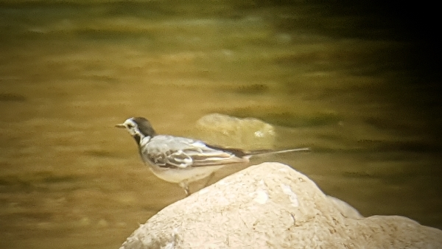
White Wagtail
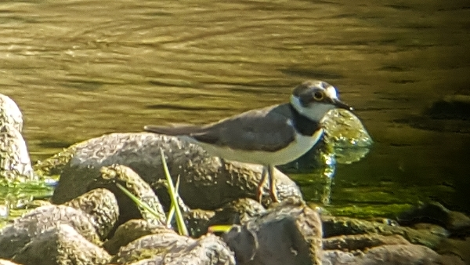
Little Ringed Plover
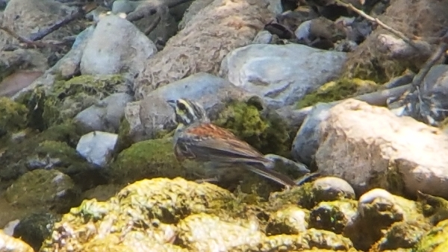
Cirl Bunting
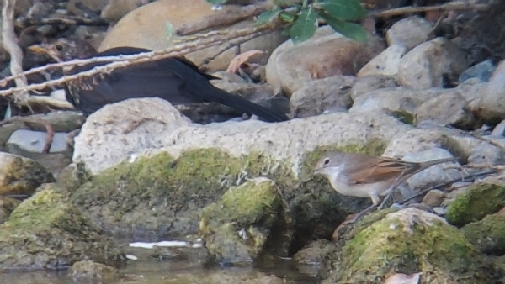
Spectacled Warbler - !st summer or female, an unusal sighting at the river, these birds do move from their breeding grounds for the winter, they are partial migrants
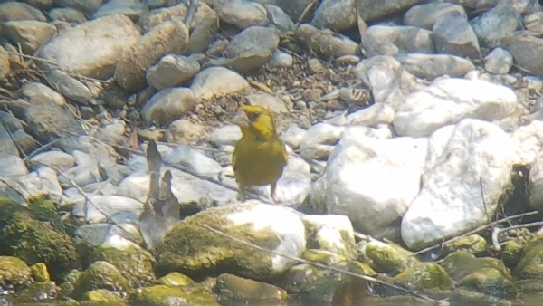
Greenfinch
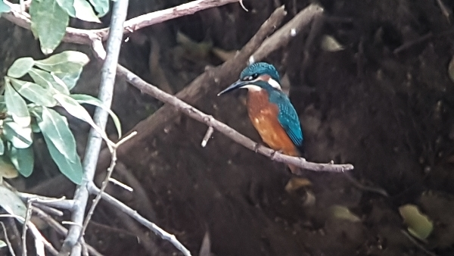
Common Kingfisher
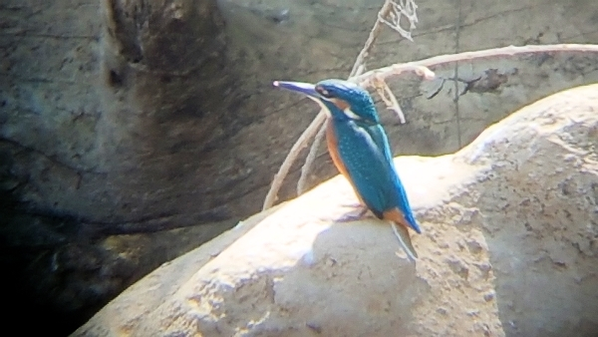

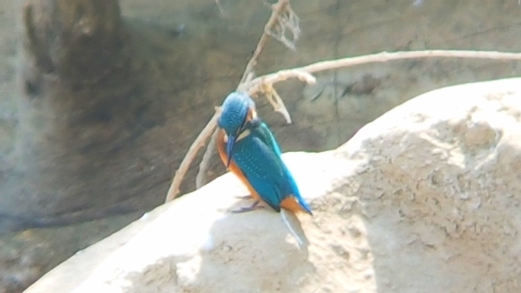

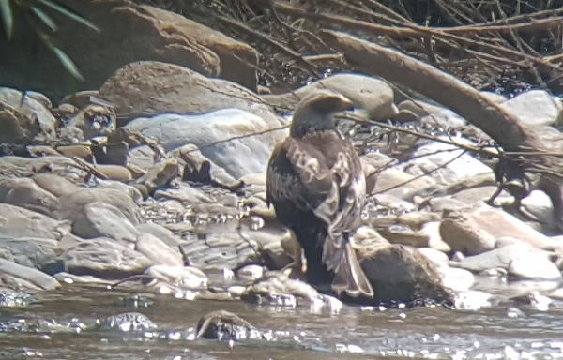
Booted Eagle - 1st year bird, never seen one here in the past coming down to drink
All these species were seen and photographed from a sitting position on the river bank - they were phone-scoped usinf a Samsung S7 phone and a Swarovski 95 scope.
Later in the day we saw large flocks of Black Kites drifting over the village towards the coast and Gibraltar. Increasing numbers of Bee-eater flocks and Black Kites are being recorded everyday, migrations is gathering momentum.

